Smart Eating

**Final Report**

Project group 10

Sindhu Reddy Golconda - 14

Ravi Kumar Kurva -- 23

Uday Kiran Chowdary Mallineni - -28

Advaith Nandelli- - 34

CS5551 - Advanced Software Engineering

University of Missouri - Kansas City

December 5, 2016

Contents

I. Introduction 3

II. Objectives 3

III. Project Deployment & Project management 4

Project Deployment - User Manual: 4

Project Management Report: 20

Final Project Evaluation: 25

Existing Services/Rest API: 25

Management Structure: 26

Project Contribution: 27

IV. Project Design: 29

Wireframes 29

Architecture Diagram: 42

UML Class Diagram: 43

UML Sequence Diagram: 44

V. Project Deployment: 45

Android Application: 45

Web Application : 55

Server Implementation: 58

VI. Presentation Slides: 59

VII. GITHUB URL: 61

VIII. YouTube URL: 61

IX. Bibliography: 62

# Introduction

Smart Eating is an android/web application which is used to find the recipes and search restaurants based on his choice. The user can get a list of recipes based on the keyword he gives and then by selecting a recipe, he can get a list of ingredients which are used to make a recipe and the process of preparing it.

The list of restaurants is obtained based on the location and food item given by the user. From the resultant restaurants, user can get menu and reviews. The user can also add his personal review.

A person might have allergic reaction towards few food items like peanuts, milk, eggs, etc. and he must be very careful while consuming the food. Hence, this application provides the user to add items which are allergic to user so that the application can highlight the items which are allergic to him. Thus, the user can differentiate what to eat and what not to.

The application smart eating also provides an option for translating the text for travelling users so that they can know each item in detail.

# Objectives

The main goal of the project is to develop a smart eating system which initially allows the user to find a restaurant by selecting a location, range of miles within which the restaurant should be searched, type of the restaurant which can be selected from a dropdown menu containing the details like Mexican, Chinese, Italian, Indian. Then the user can select all the allergies he has towards food and also the diseases he has.

A list of restaurants is populated based on the search criteria. Menu of the selected restaurant is then displayed which contains the details of all the food items and also it will suggest the user whether the food item contains the ingredients that are allergic to user and also if the item is healthy or not based on his diseases.

# Project Deployment & Project management

## Project Deployment - User Manual:

Unser Manual Contents:

1. How to Start Smart Eating Application:

2. User Registration

3. Login to the Smart Eating application:

4. Home Page

5. Search Recipe

6. Manage allergies

7. Search Restaurant.

I. Get Menu

II. Get Review

8. Translate

8. Change Password:

9. About us:

1. How to Start Smart Eating Application:

To start the Smart Eating application please follow the below mentioned steps.

* 1. Click on the **Smart Eating icon** on application menu.
  2. After clicking the Smart eating icon, the application will starts

and Login page will display.

* 1. Login page contains below options.

1. Login
2. Register
3. Login with Facebook
4. Login with Google

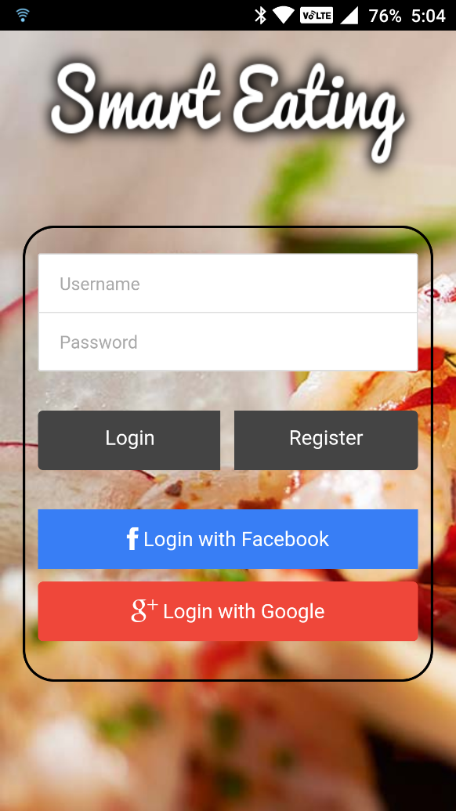

2. User Registration

If the user doesn’t have an account he/she must Register the steps are shown below.

1. Start the **Smart Eating** application.
2. The login page will have displayed.
3. Click on the **Register button** on the page.



1. On click the Registration page will displayed
2. Enter the following details in the register page and press Register Confirmation button in Register page.
   1. First Name
   2. Last Name
   3. Mobile Number
   4. User Name
   5. Password

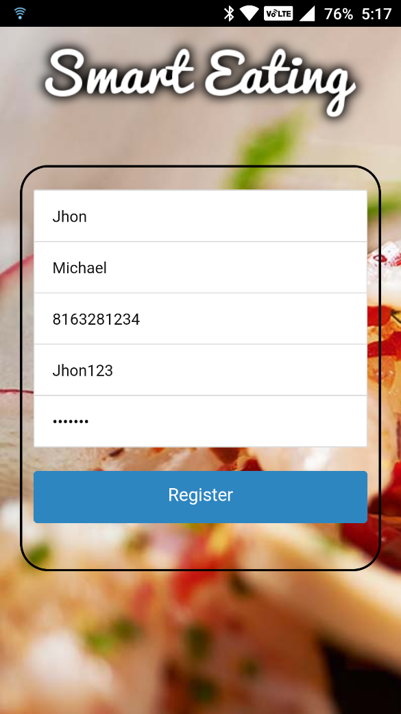

1. The application will store the user information and displays the feedback to the User weather it was Successful or Not.

3. Login to the Smart Eating application:

To login in to our Smart Eating application follow the below steps.

1. Start the Smart Eating application. And it will display the login page.
2. Enter the valid Username and Password in the fields and press **Login button**.

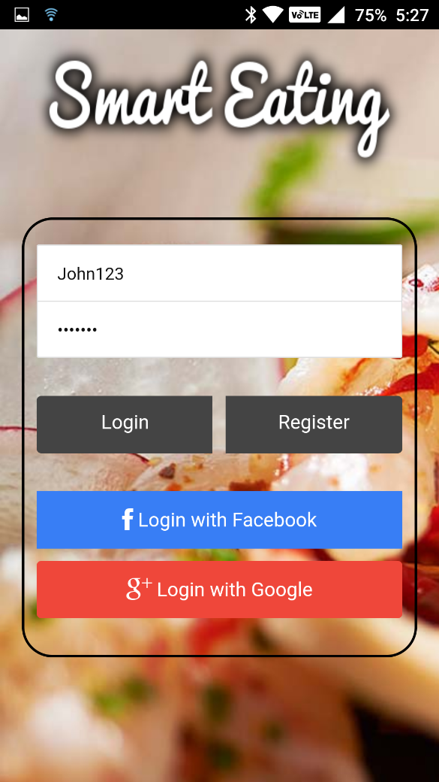

3. It will validate the User information.

4. If the given information is correct the login successful popup message will display.

4. Home Page

After successful login It will redirect to Home page which contains all the different features.

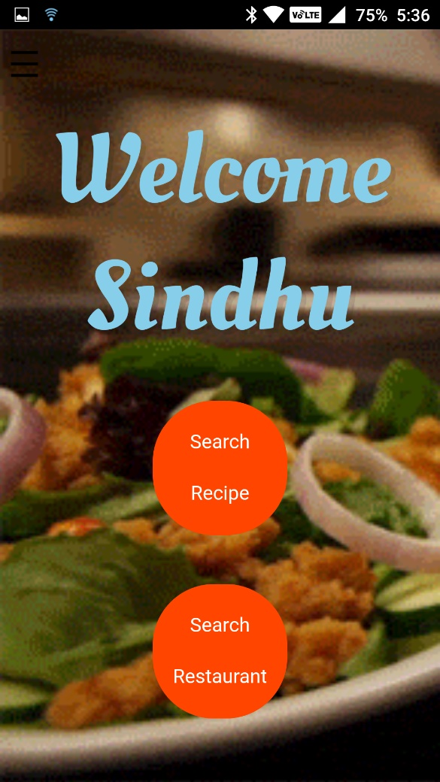

5. Search Recipe

To search the recipe, follow the below steps.

1. Start the Smart Eating application.
2. Login into the application. After successful login, the home page will be displayed.
3. Click on the **Search Recipe** icon. On clicking the button, it will display Recipes page.

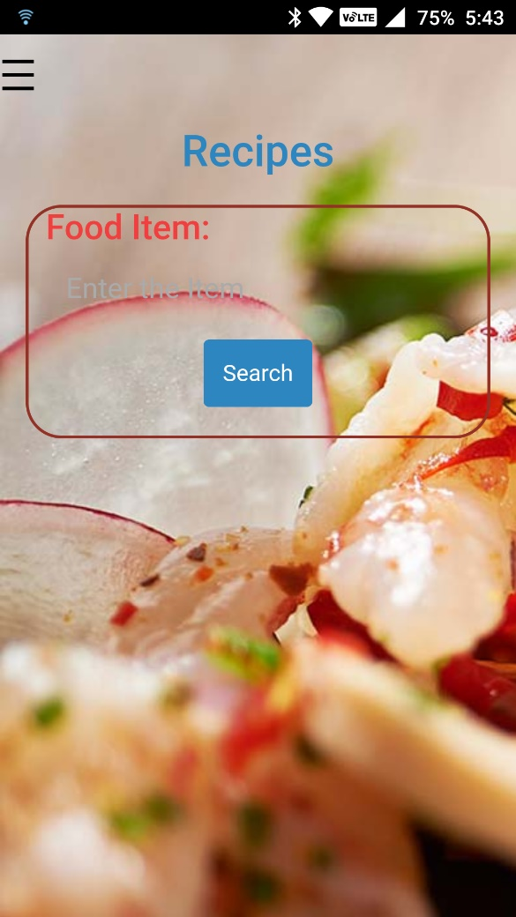

1. The page will have the Food item field where you can enter the food item name which you want to know the ingredients.
2. On clicking the Search button all the search results will displayed containing the items names.

6. Manage allergies

To access the allergy information, follow these steps.

1. Open the Smart Eating application and login with the valid credentials
2. On clink of **login button** home page will displayed
3. Then clink on the **menu button**
4. it will show the side menu it contains the Allergies link
5. On clicking that link you will redirect to the Manage Allergies page

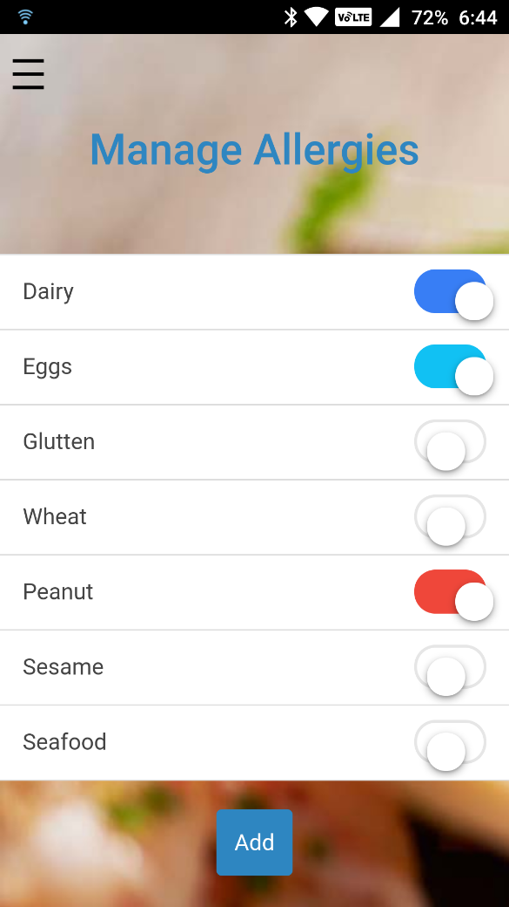

7. Search Restaurant.

* 1. To Search Restaurant please follow the below steps.
  2. Start the Smart Eating application.
  3. Login to the application with valid credentials. On successful login Homepage will displayed.
  4. Click on the Search Restaurant button on this page. On clicking it will open the Search Restaurant page.
  5. Enter the place where you want to search and item name click Search button it will display the top 5 restaurants near to you.

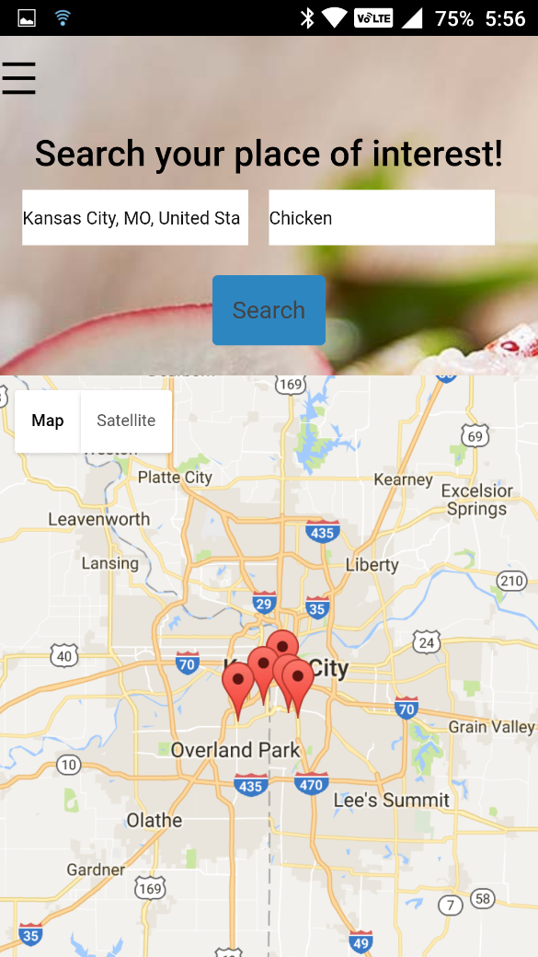

I. Get Menu

To get the menu follow the below steps.

* + 1. Open the application and login with the valid credentials
    2. On click of the login button it will displays the home page and press the Search Restaurant button
    3. It will displays the another page with place and food item. Enter the information and press the Search button

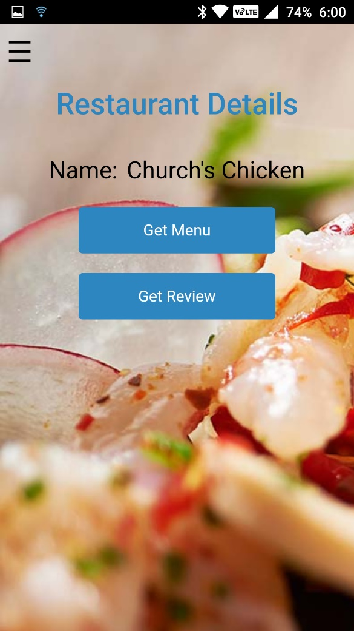

* + 1. Click on the Get Menu button to get the menu of the above-mentioned restaurant.
    2. On click of button all the menu will displayed.

II. Get Review

To Get the review of the restaurant follow the these steps

1. Open the application and login with the valid credencials

2. On click of the login button it will displays the home page and press the Search Restaurant button

3. It will displays the another page with place and food item. Enter the information and press the Search button.

4. On click of the button it will redirect to Restaurant Details page.

5. Press the Get Review button to the Review of that restaurant.



8. Translate

To Access the Translation feature, follow the below steps

* + - 1. Open the Smart Eating application and Login.
      2. After login, the Home page will displayed in that page press the Side Menu button it will navigates to side menu which contains Translate option.

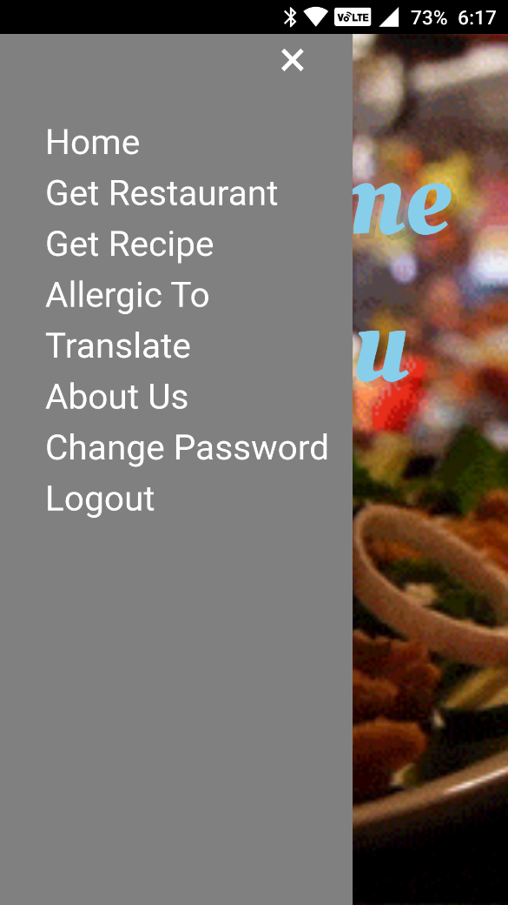

* + - 1. Press the translate link and it will redirect to another page.
      2. In this page user, can translate the words from one language to another language.

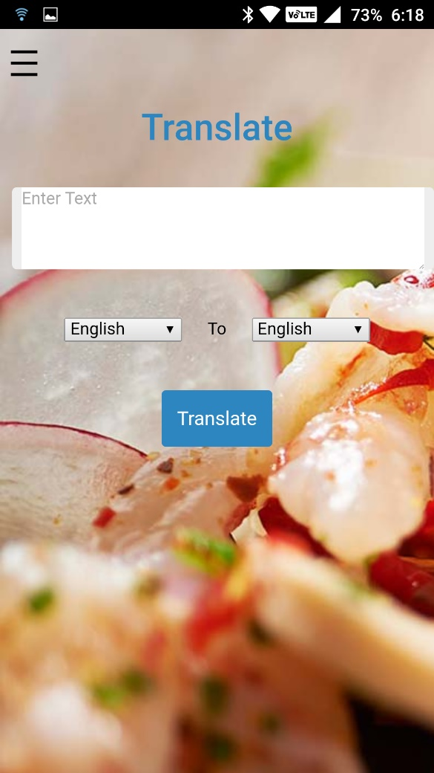

8. Change Password:

To change password, follow the below steps.

1. First open the application and login with the valid credentials
2. It will display the home page in the homepage open the side menu button
3. It will open the side menu of our application
4. In the side menu click on the change password link
5. On click it will displays the update password page with following the fields
   * 1. Enter Old password
     2. New password
     3. Re-Enter New Password

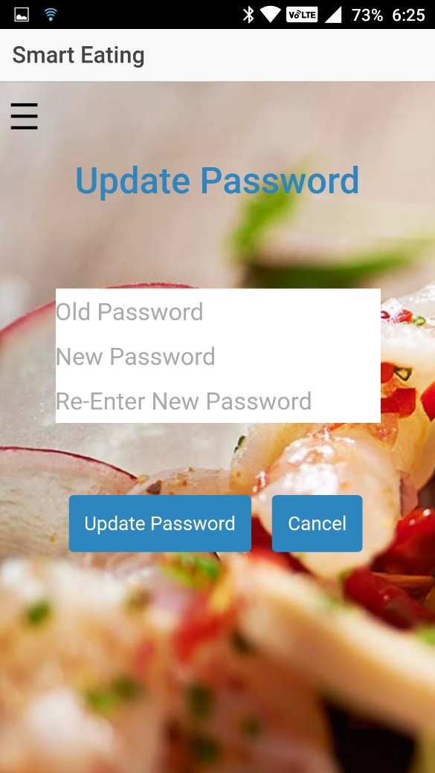

f. After filling all these fields enter the Update password button.

g. On clicking that button your password will update successfully.

9. About us:

To access the About US follow these steps.

1. Open the application and login with valid credentials.

2. On click login button home page will displays.

3. Next click on the side menu button it will shows the side menu.

4. Click on the About us link and it will redirect to the About us page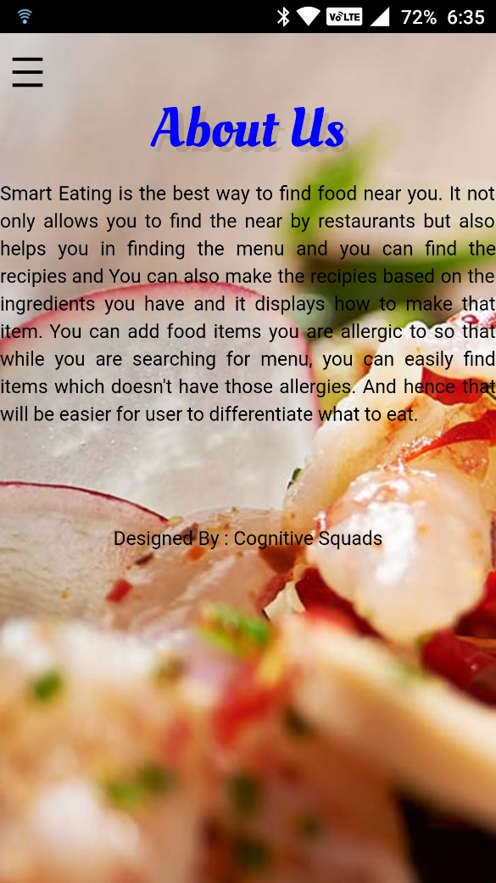

## Project Management Report:

The project is done in four increments, where in each increment the tasks are divide between the team members which is done in Zenhub. The screenshots of zenhub board for each increment are given below.

ZenHub Board for Increment 1:

Using Github and Zenhub, Issues for first Iteration are Created. The Zenhub board consisting of all the issues is listed as shown below.

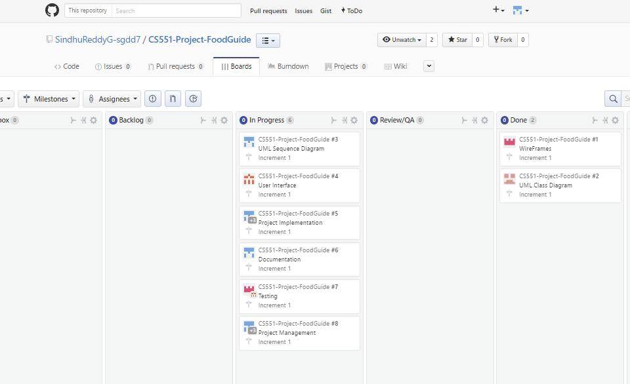

Zen Hub Board up to Increment 2 :

Using GitHub and Zen hub, Issues for Second Iteration are Created. The Zen hub board consisting of all the issues is listed as shown below.

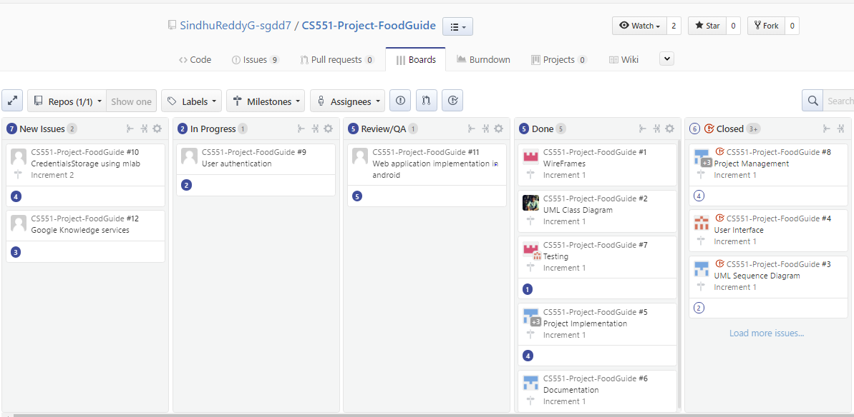

Zen Hub Board up to Increment 3:

Using GitHub and Zen hub, Issues for Third Iteration are Created. The Zen hub board consisting of all the issues is listed as shown below.

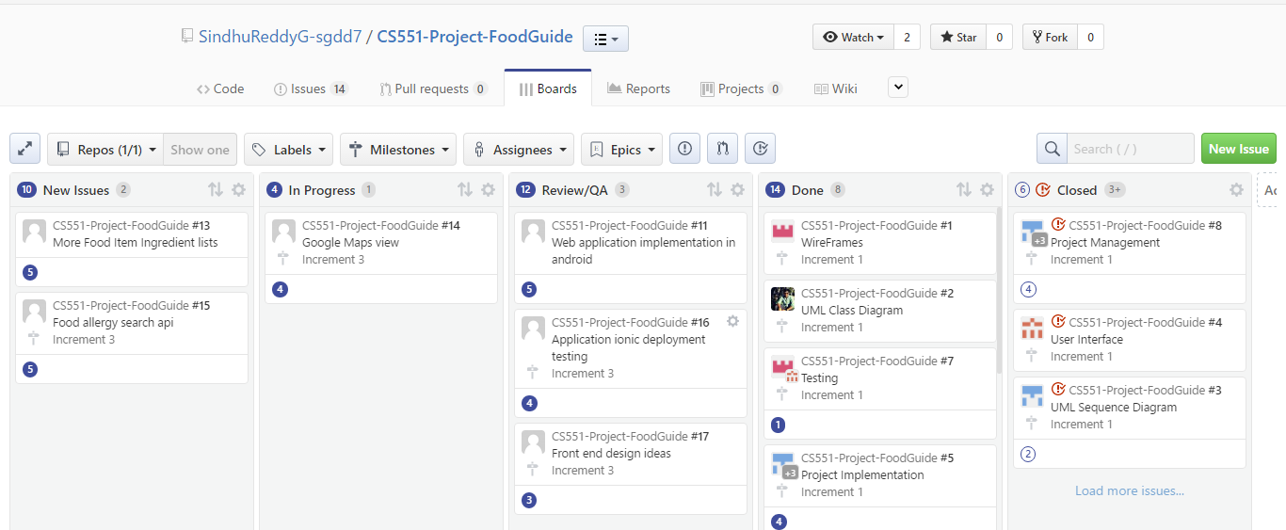

Zen Hub Board up to Increment 4:

All the issues regarding about our project are done and closed, all the closed issues are posted down below.

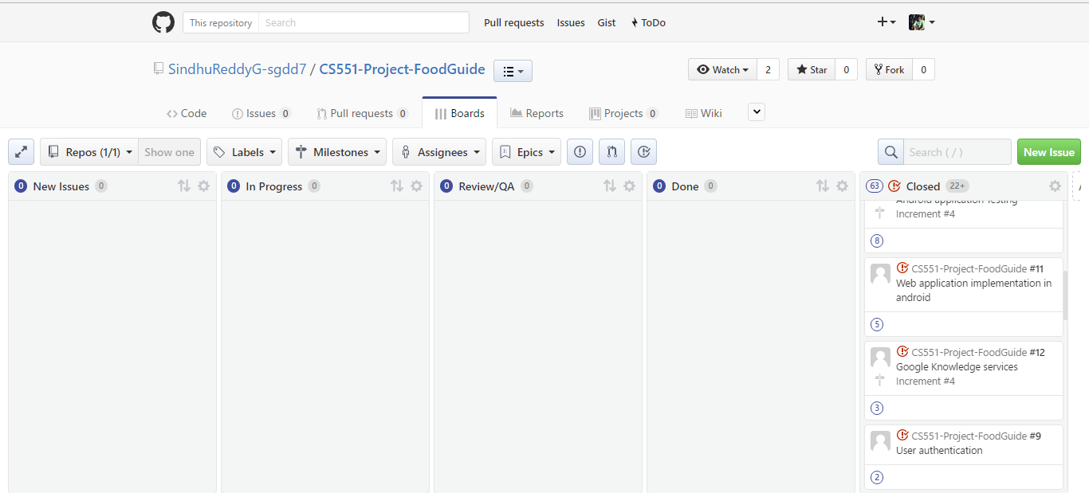

Burndown Chart for Increment 1

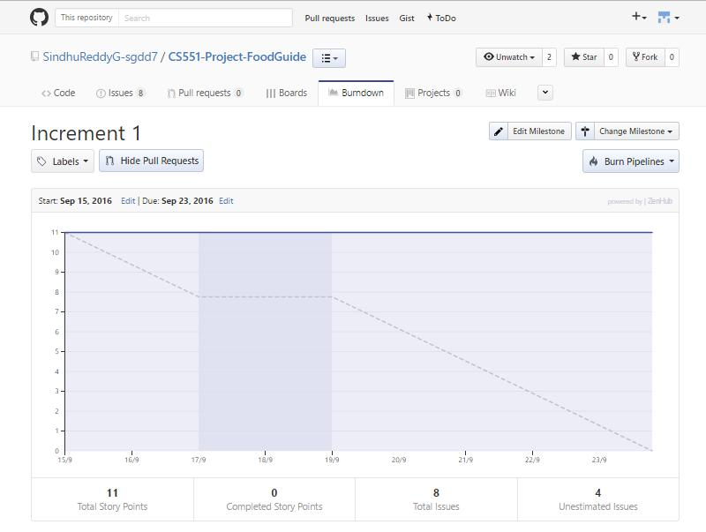

Burndown Chart for Increment 2:

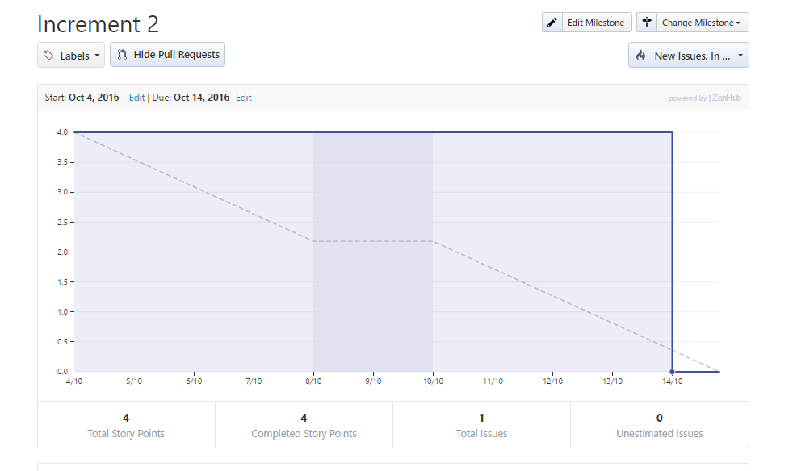

Burndown Chart for Increment 3:

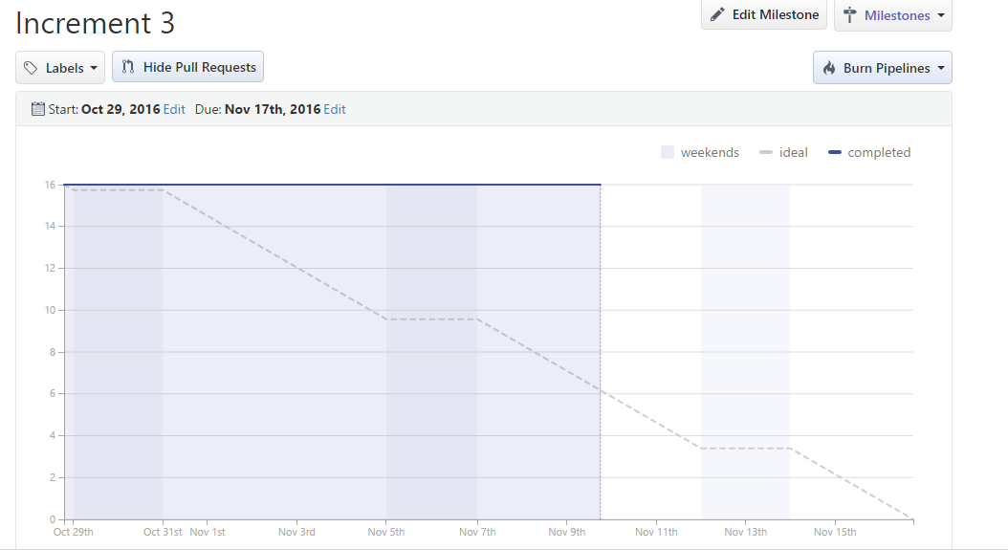

Burndown Chart for Increment 4:

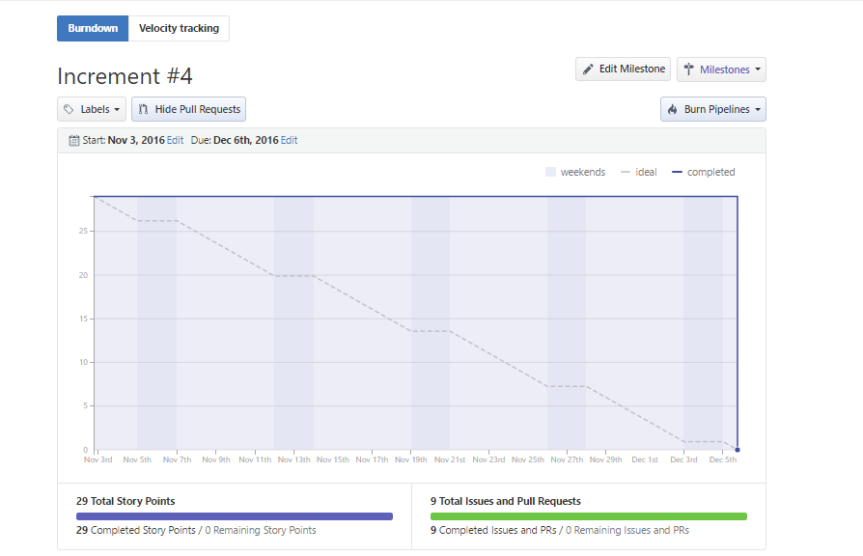

## Final Project Evaluation:

### Existing Services/Rest API:

1. Foursquare API:
   * Used for retrieving Restaurants based on location and search query.
   * Also used for getting categories and menu items for a specific restaurant.

URL:  [https://api.foursquare.com/v2/venues](https://api.foursquare.com/v2/venues/)/

1. Google Knowledge graph search API:
   * Auto population of data in the textfield is implemented using this API. URL:  [https://developers.google.com/knowledge-graph](https://developers.google.com/knowledge-graph/)/
2. Edamam API:
   * This API is used to get ingredients for the different food items.

URL: <https://developer.edamam.com/>

1. The Yummly Recipe API :
   * It is used to get all the recipe’s and ingredients of the food items.

URL: <https://developer.yummly.com>

1. Mlab online database service
   * By using this service, we are implementing the online user account database to login

URL: <https://mlab.com/databases/SmartEating>

1. Google Maps API

* We are using the google maps API to display the restaurant location in google maps.

URL: <https://developers.google.com/maps/>

### Management Structure:

* **User account database development :** User account details are stored in the mlab’s online mongo database.
  + Contributors: Advaith, Ravi
* **User credentials validation test cases:** User login credentials are validated with the values in database of mongo lab.
  + Contributors: Sindhu, Uday
* **Web application User Interface: F**ront end idea and implementation of webpages in html.
  + Contributors: Uday, Advaith
* **Android application Development: F**ront end idea and implementation of android application design idea in mobile.
  + Contributors: Sindhu, Ravi
* **Application Program Interface Use Cases:**  Implementation of different use cases from the Web API like ingredient search, items and allergy’s.
  + Contributors: Sindhu, Ravi, Advaith, Uday
* **Restaurant Search implementation:** Using Foursquare API, the restaurants are retrieved

based on location and search query.

* + Contributors: Advaith, Ravi, Sindhu, Uday
* **Menu and Item Search implementation:** For the selected restaurant, Menu is retrievedwhich contains different Categories of items using foursquare API. By selecting the Category, all the items belonging to particular category are displayed.
  + Contributors: Uday, Sindhu
* **Android Application deploying and debugging** : We had deployed our application in android platform using Ionic.
  + Contributors: Sindhu, Ravi.
* **Web Application deploying and debugging:** We had deployed our Application in browser as well. Also debugged when errors occurred.
  + Contributors: Sindhu, Ravi, Advaith, Uday
* **Application testing:** Deployed application is then tested using JLint and YSlow for better performance.
  + Contributors: Advaith, Uday
* **Restaurant Review:** Reviews of selected restaurants are retrieved using IBMWatson API.
  + Contributors: Uday, Sindhu

### Project Contribution:

Sindhu Reddy Golconda (Class ID: 14) :

Contribution: 25%

Responsibilities:

* User credentials validation test cases
* Android application Development
* Application Program Interface Use Cases
* Restaurant Search implementation
* Android Application deploying and debugging
* Restaurant Review

Ravi Kumar Kurva (Class ID:23)

Contribution: 25%

Responsibilities:

* User account database development
* Android application Development
* Application Program Interface Use Cases
* Restaurant Search implementation
* Android Application deploying and debugging
* Web Application deploying and debugging

Uday Kiran Chowdary Mallineni (Class ID: 28)

Contribution: 25%

Responsibilities:

* User credentials validation test cases
* Web application User Interface
* Restaurant Search implementation
* Menu and Item Search implementation
* Application testing
* Restaurant Review

Advaith Nandelli (Class ID: 34)

Contribution: 25%

Responsibilities:

* User account database development
* Web application User Interface
* Application Program Interface Use Cases
* Restaurant Search implementation
* Web Application deploying and debugging
* Application testing

# Project Design:

## Wireframes

Login page:

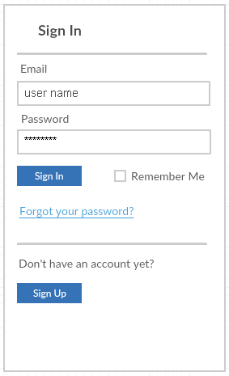

Register page:

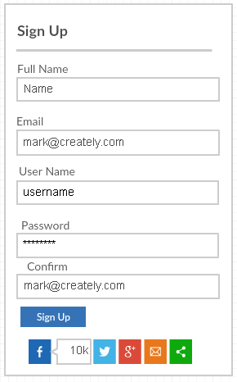

Change Password page :

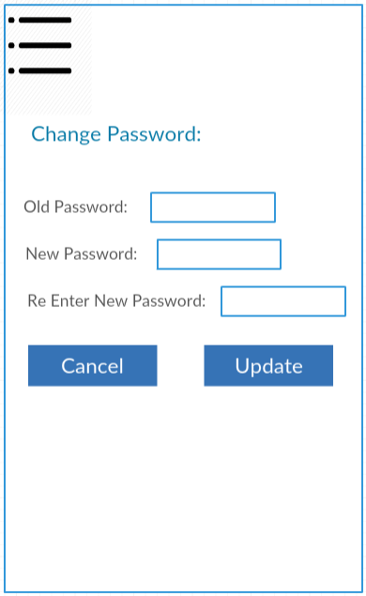

app. main search page:

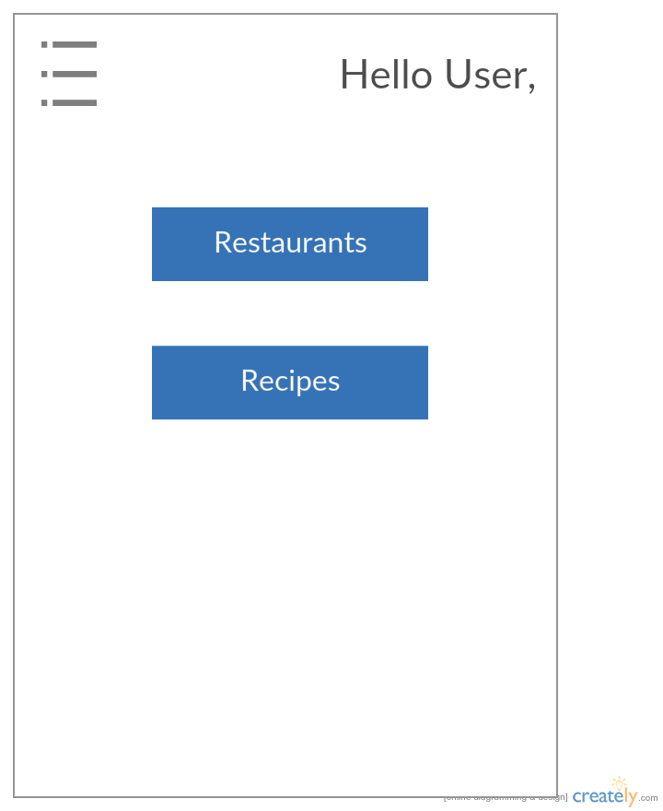

Translate Page:

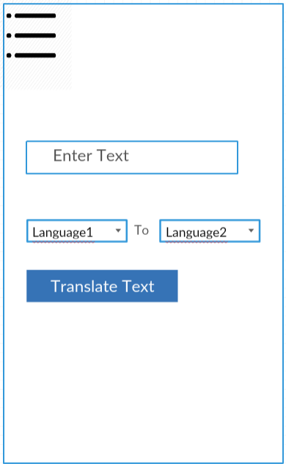

Restaurant Result page:

In this page we will display best resulted restaurants based on the given input options by the user.

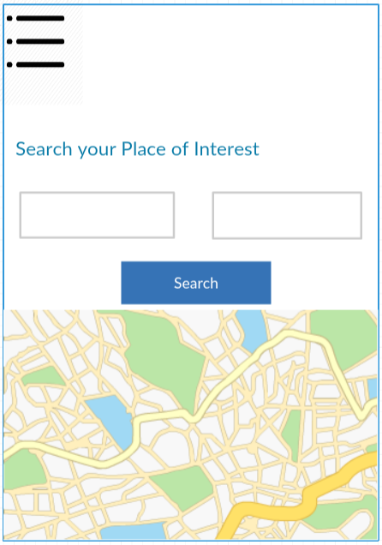

Search Result:

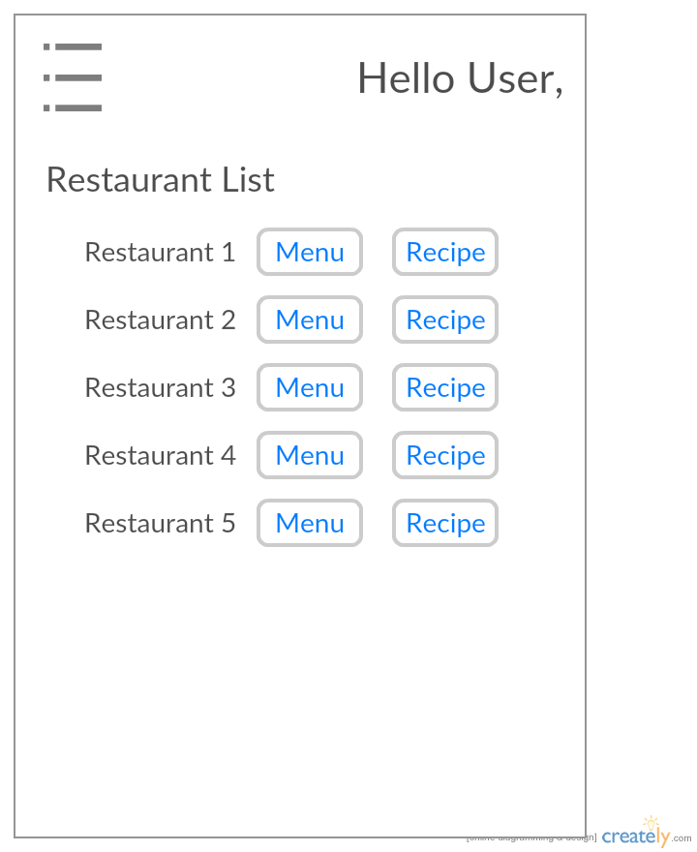

Menu page:

In this page we will display the menu with the items and health concern to give the user feedback whether is it good or bad to his health by indicating green / red mark.

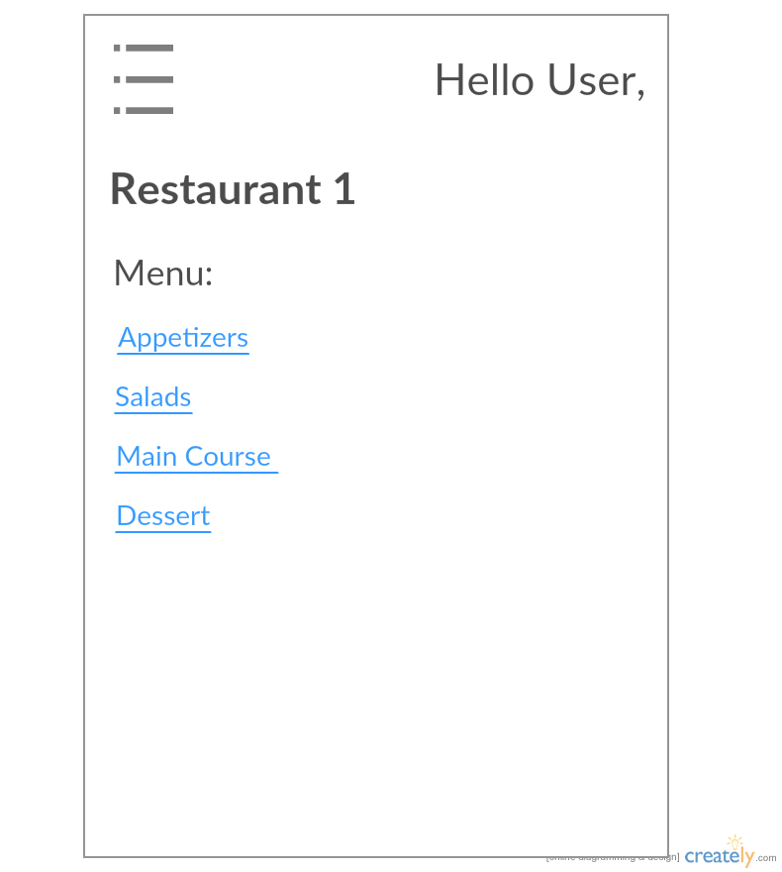

Allergic food page:

In this page user can specify the which items he his allergic so that we can give him food options without them like some members will allergic to the peanut we can give him food items list which don’t have the peanuts in it.

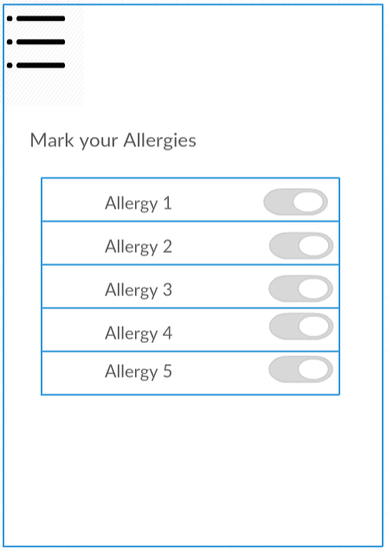

Recipe Search:

User can search the Ingredients of the Food item, So that he can prepare that food at home. Here we have used the edamam API to search the food ingredients.

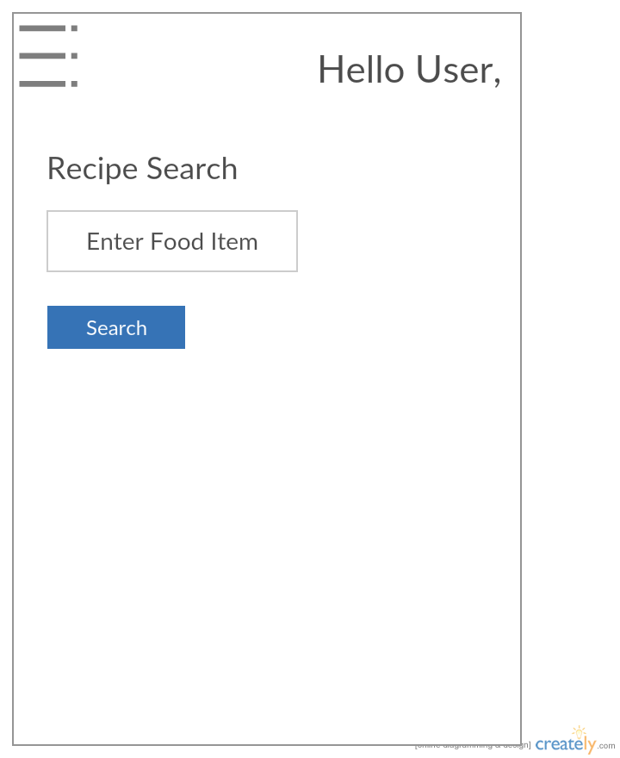

Recipe Result page:

Here user will get the relevant search results items list based on the food item.

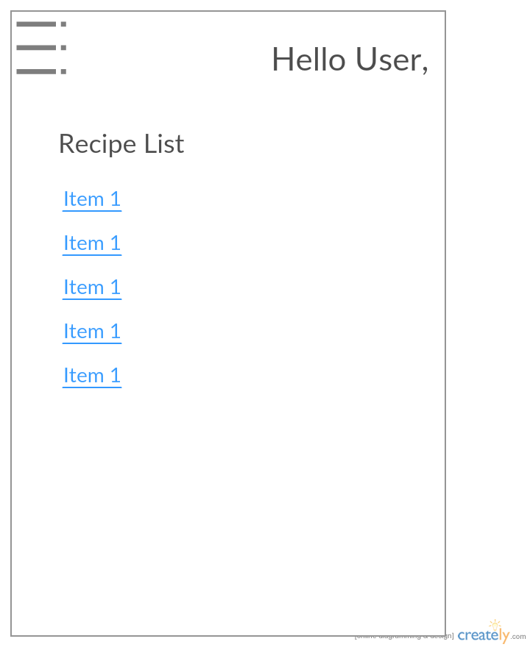

Ingredient result:

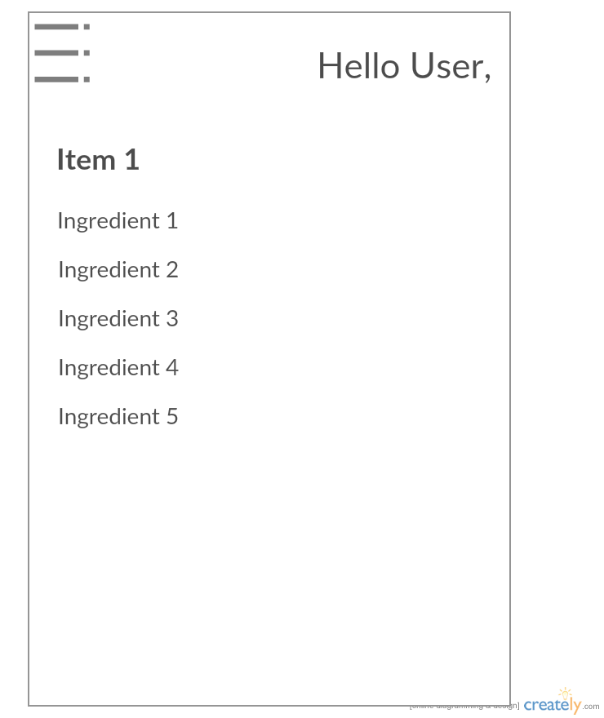

About Us Page :

In this page, we have explained about the our application and uses.

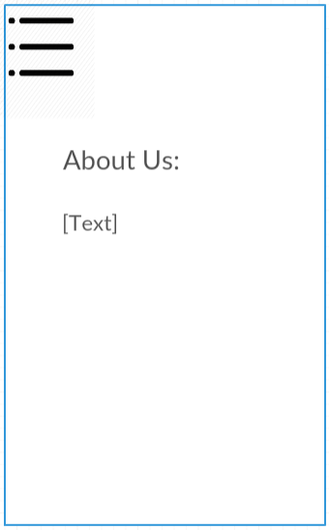1

## Architecture Diagram:

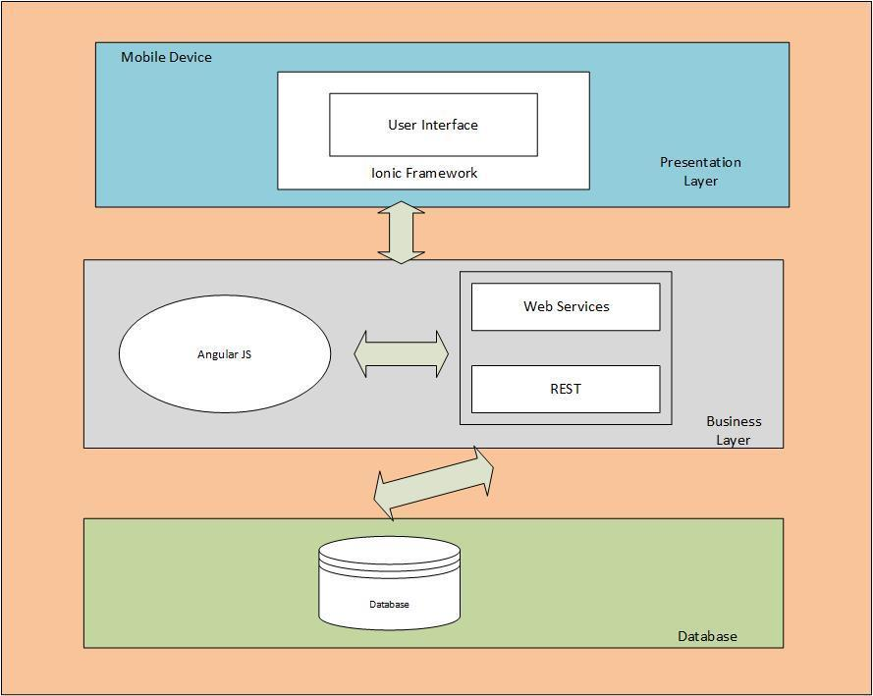

## UML Class Diagram:

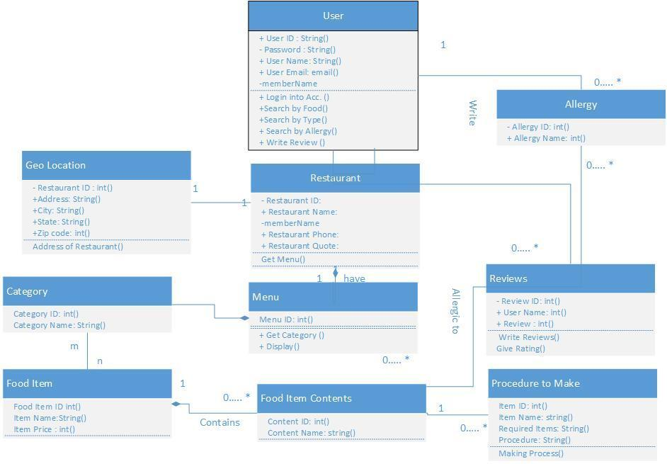

## UML Sequence Diagram:

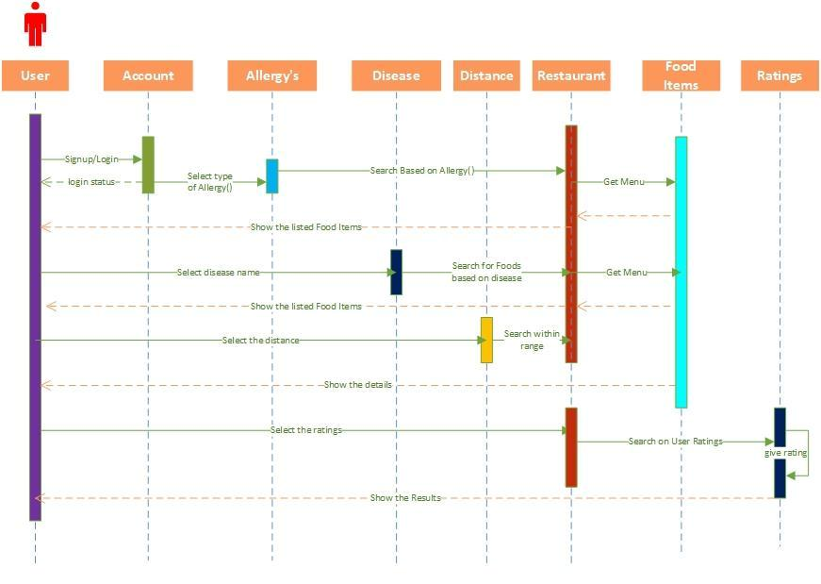

# Project Deployment:

## Android Application:

User Registration:

In this page, user can enter his/ her credentials into our application in order to sign up and all the details will be stored in the online mlab database (mongo dB).

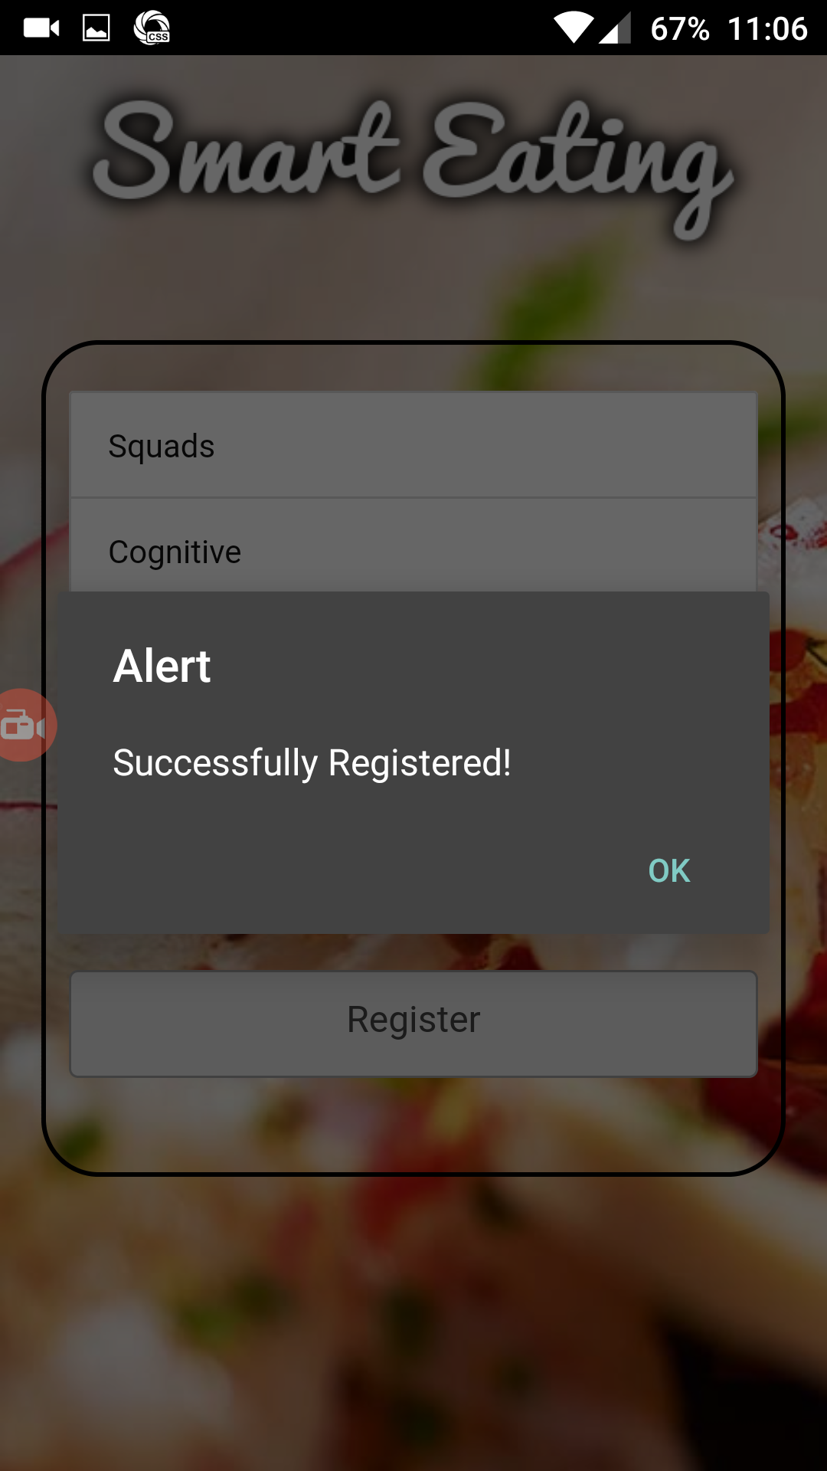

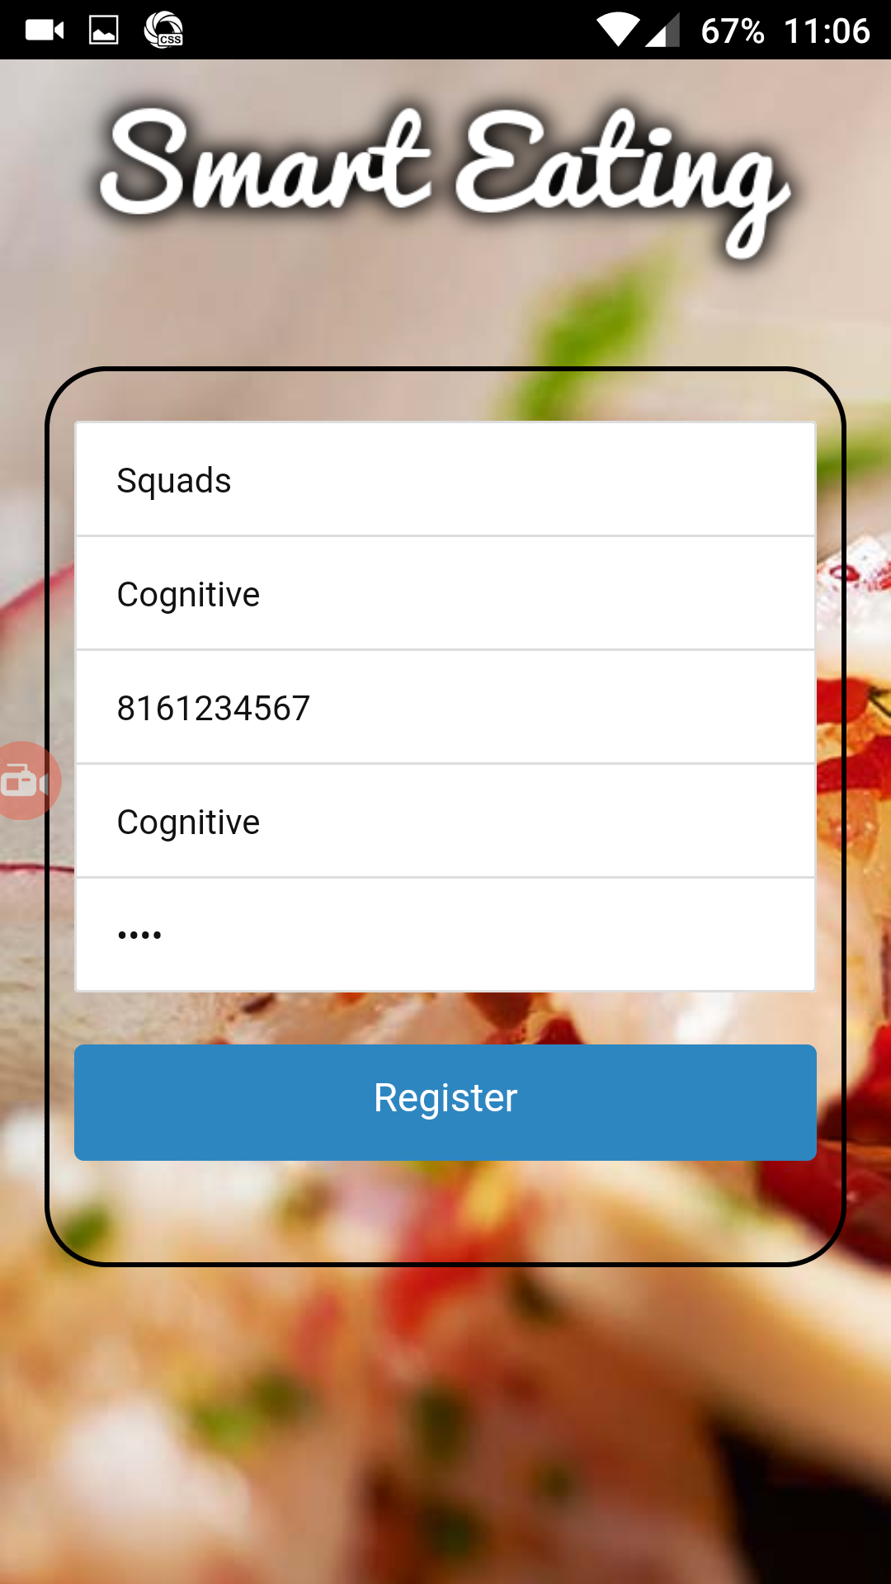

User Login:

In this page user is able to login into his account with the valid credentials.

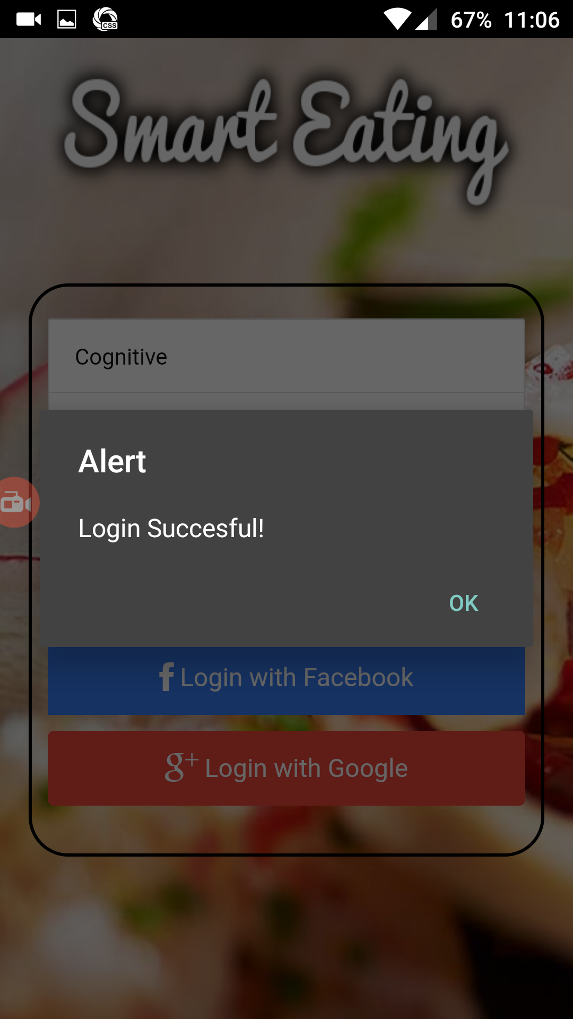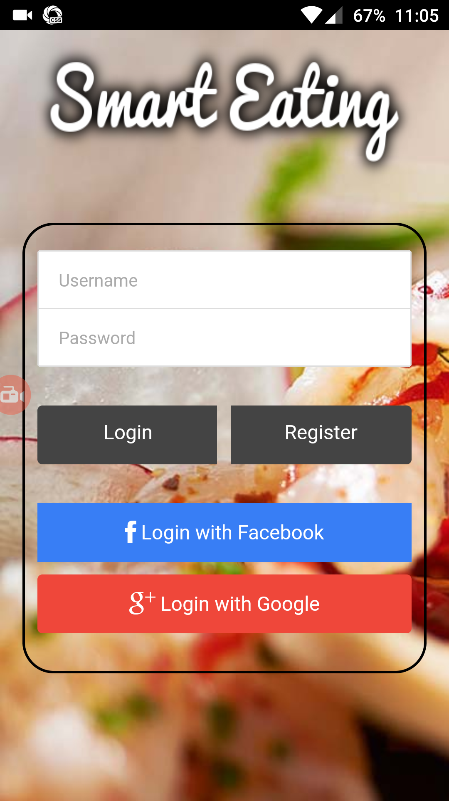

We will validate the user credentials, if they match the online database username and password it will give the user a successful login pop message and then redirected to the home page.

Home page:

In this page where user select search recipe or search restaurant to try new food.

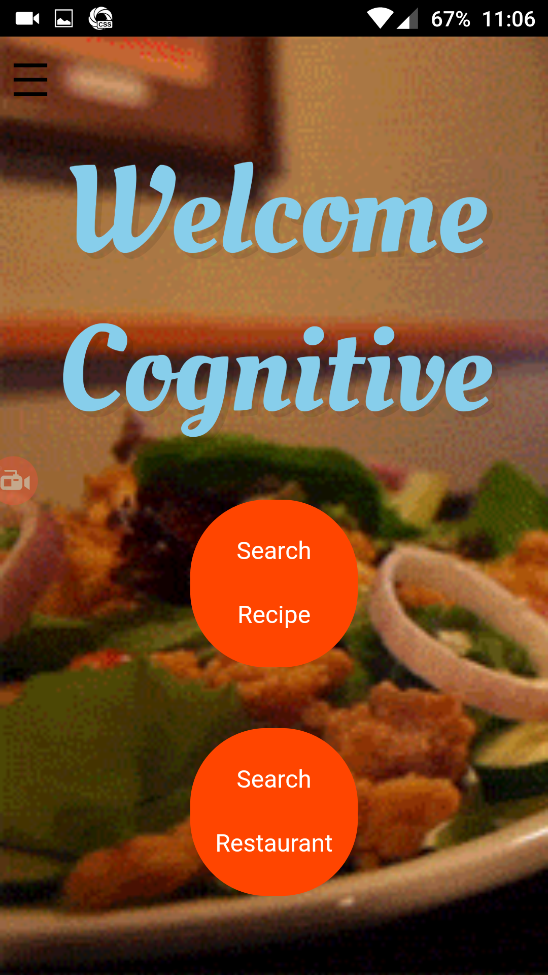 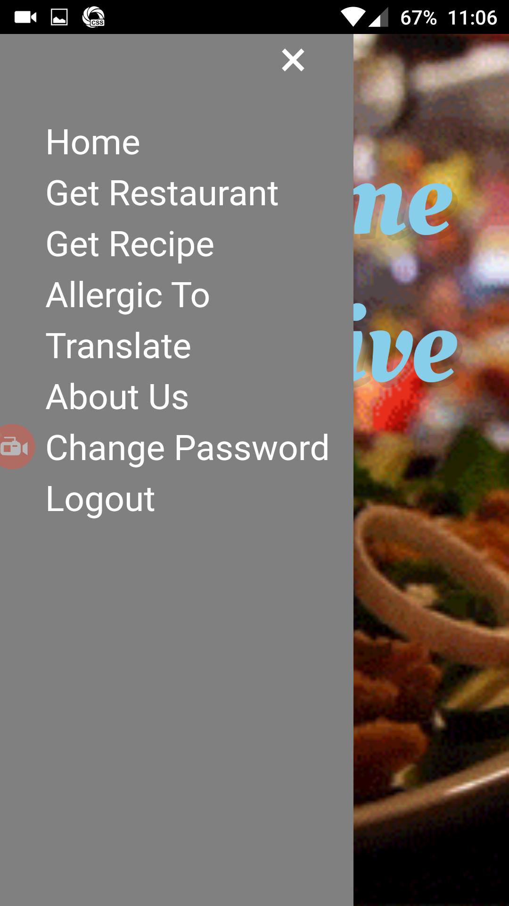

Search Recipe:

Here in this page user can search the food items to get their recipe’s

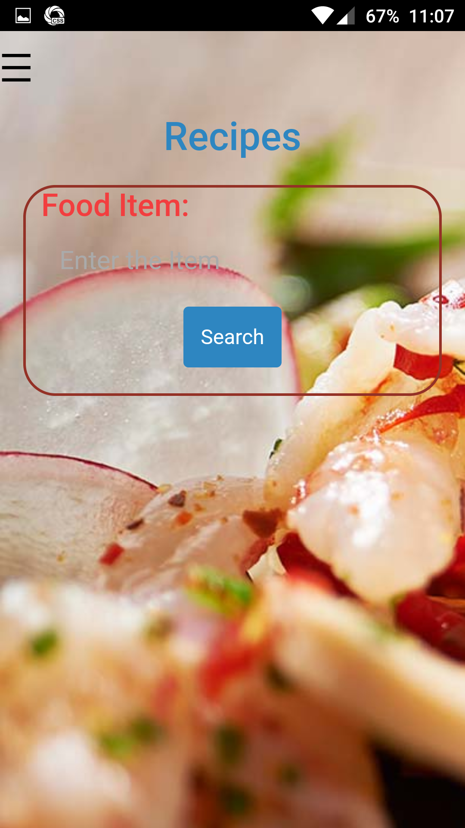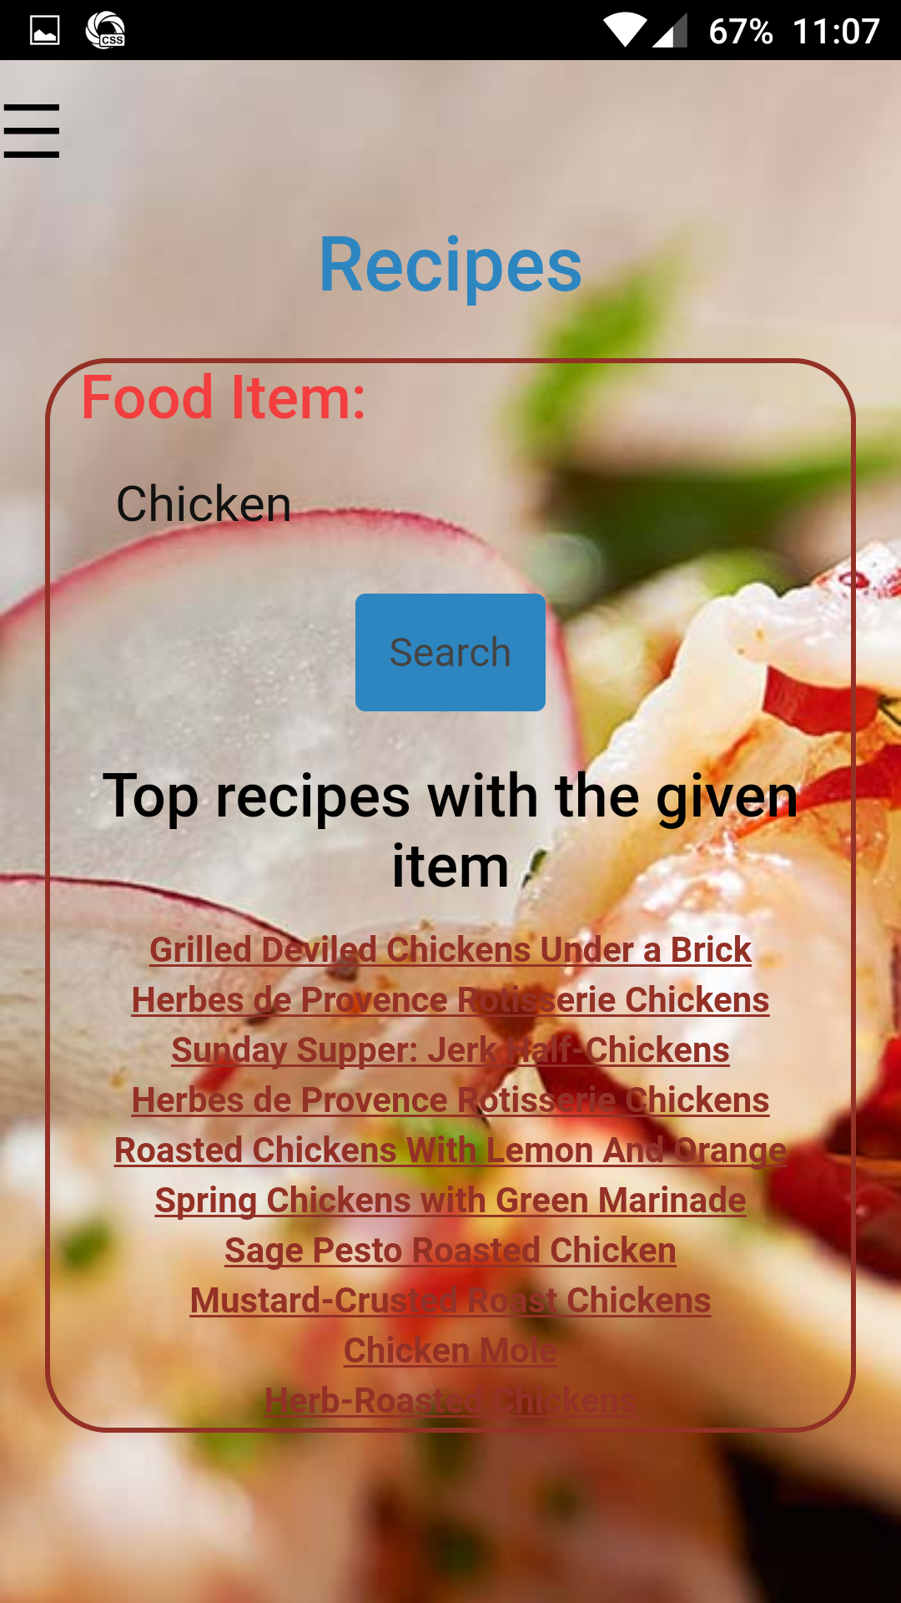

Ingredients Result :

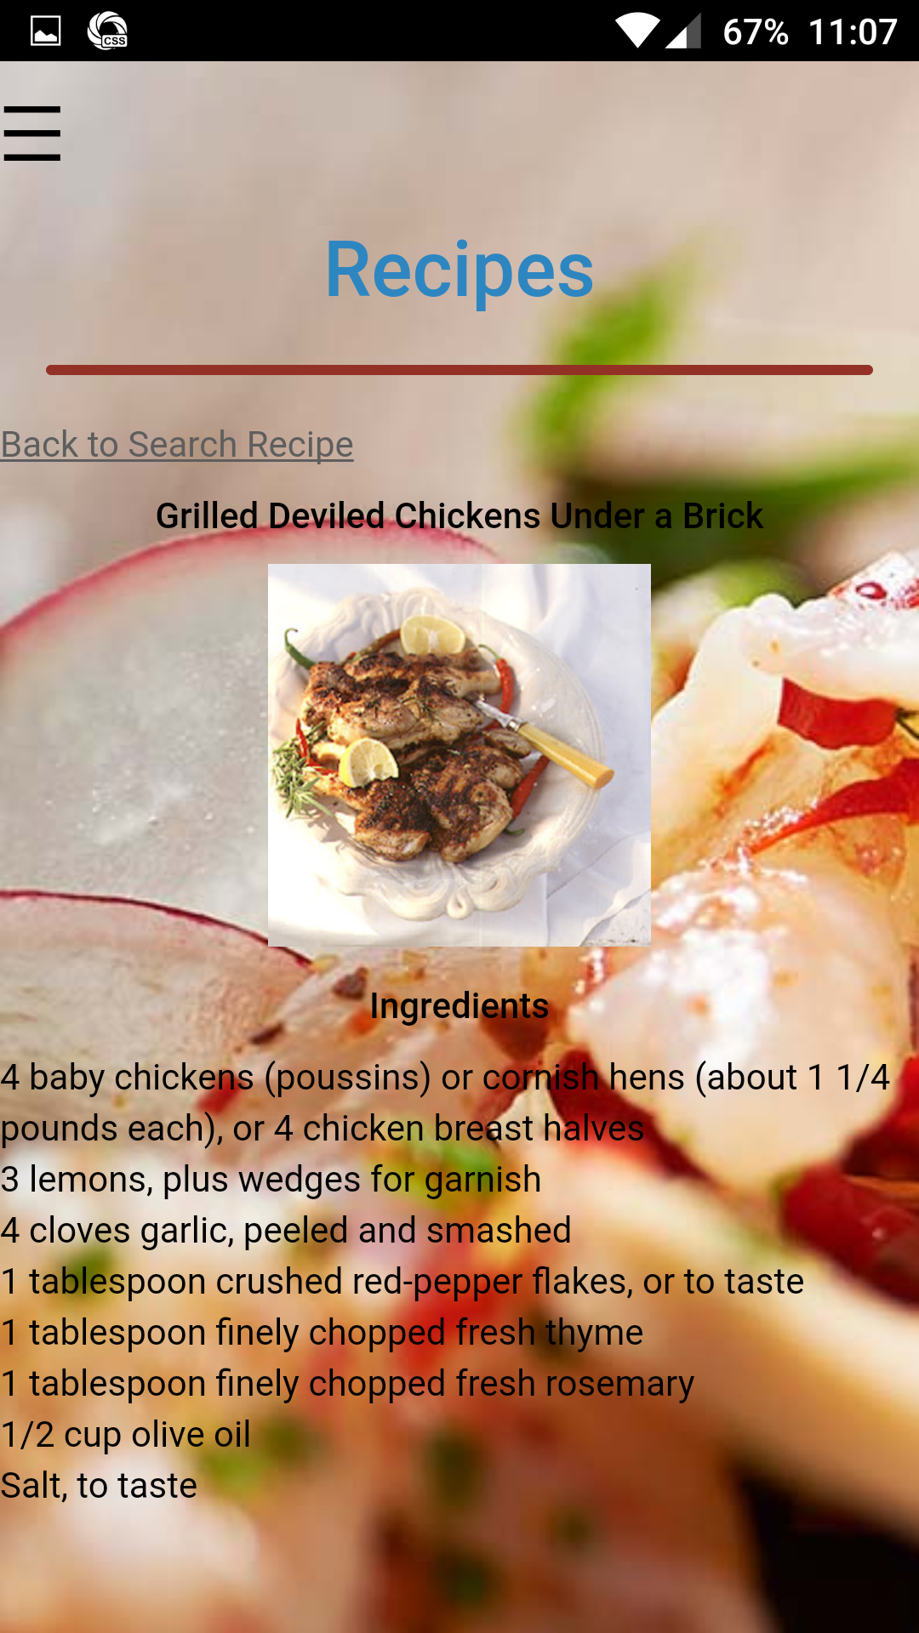

User can also get the images of the food items as well as the ingredients as shown above

Allergies :

In this page user can select the different items which are heshe allergic to.

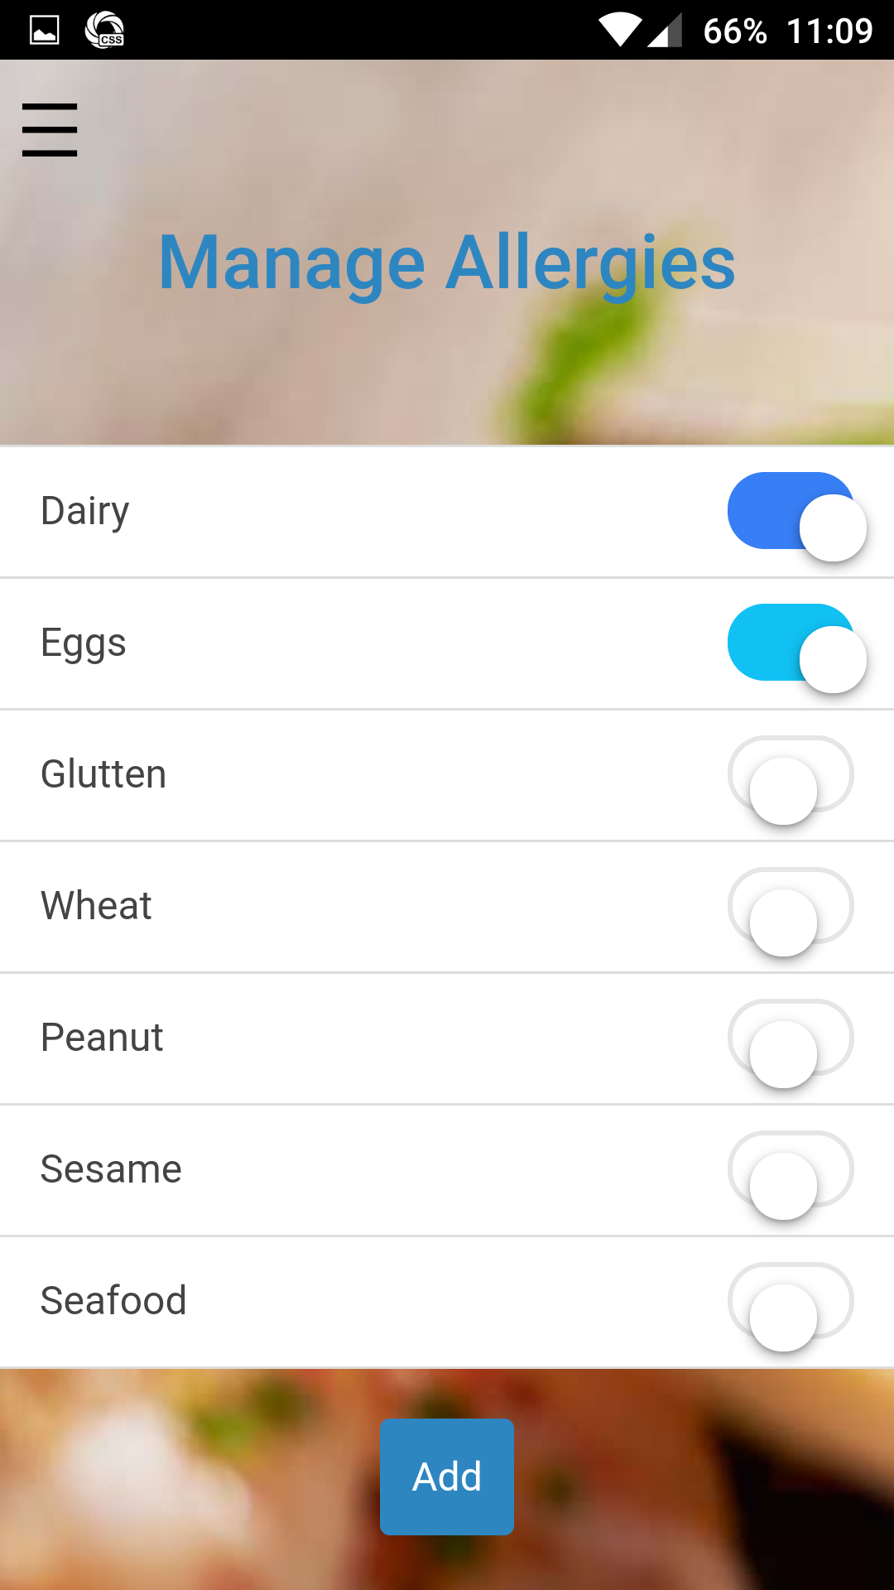

Restaurant Search:

Once he selects the place and which type of the food he wants to try we will display all the results related to the search field.

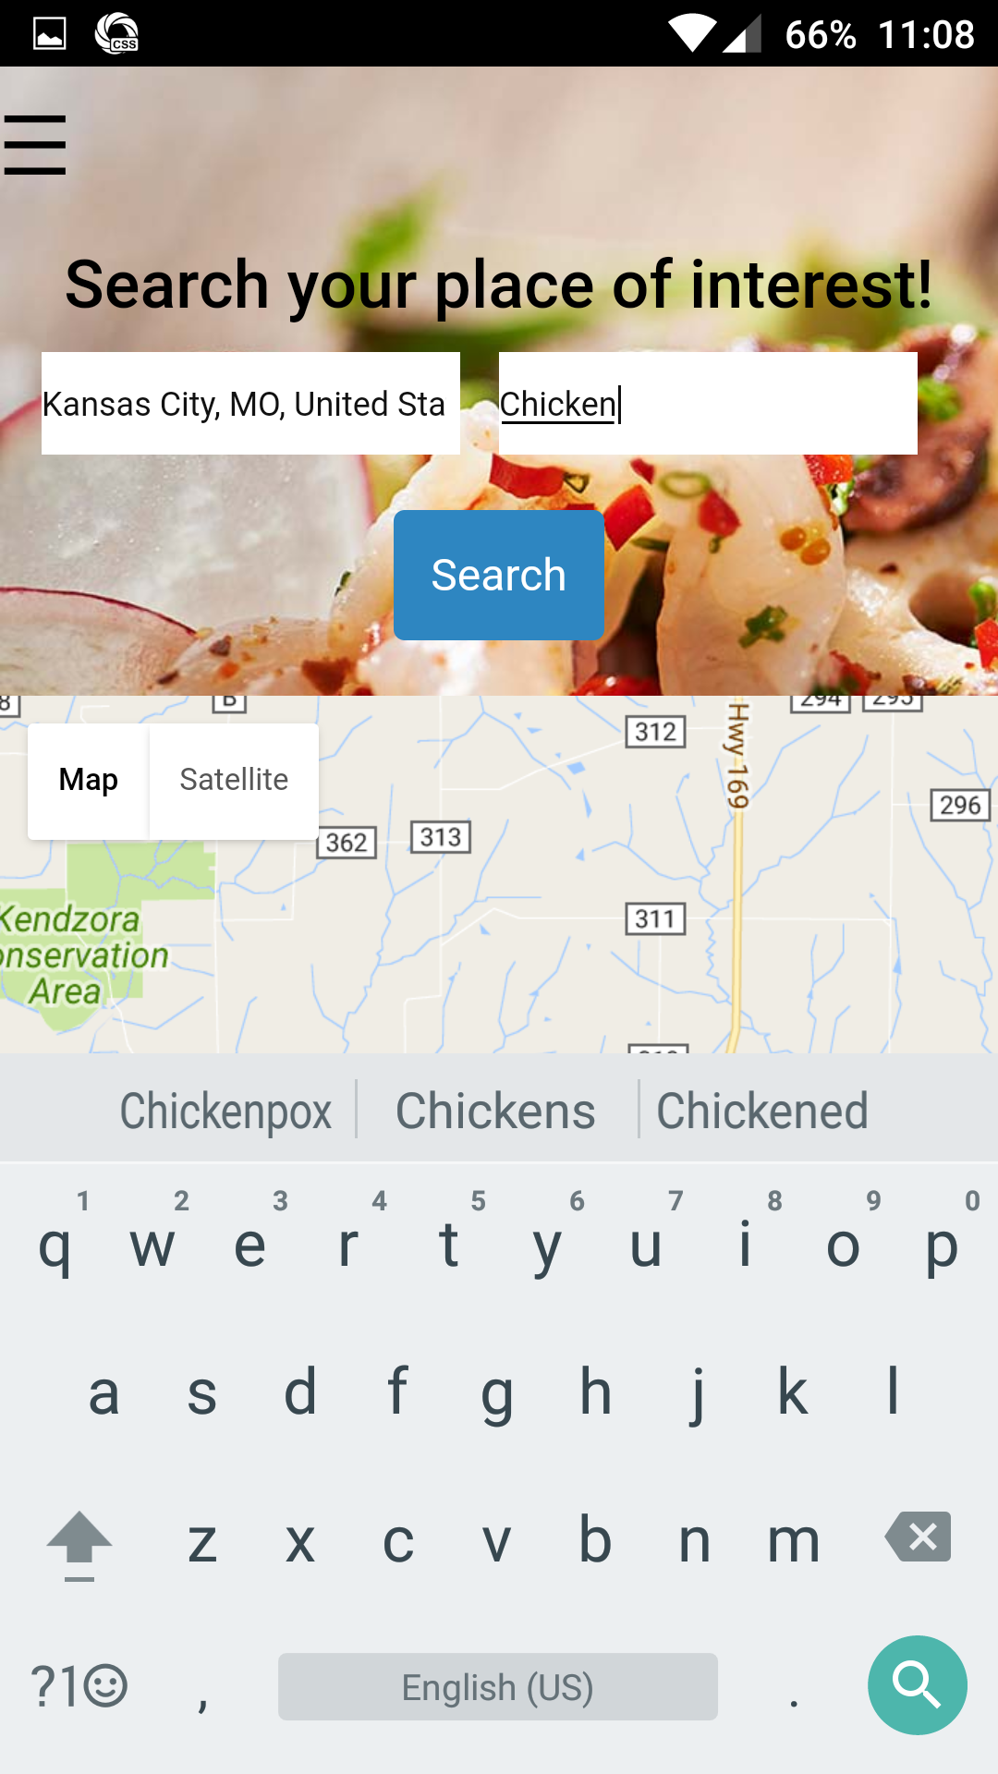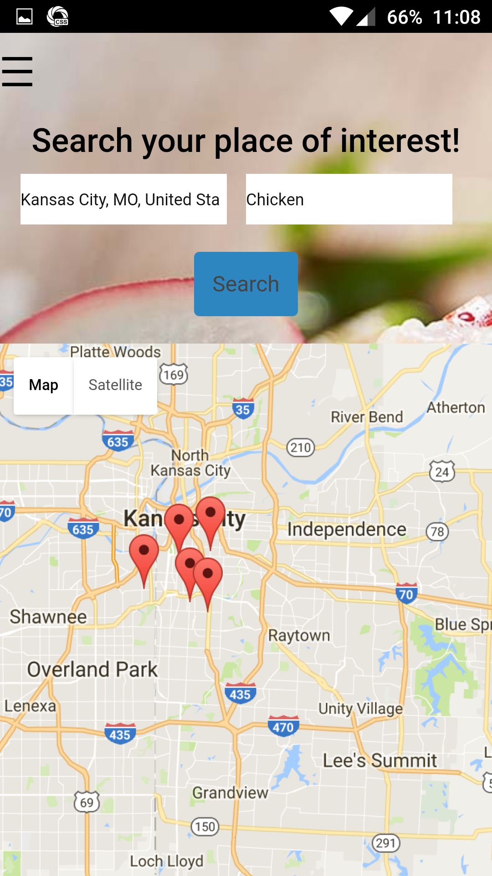

After getting the results we will display the restaurant name and menu and reviews from the previous users. Menu button will show the restaurant menu with the item names.

User Reviews/Menu : Here we will display the review of the food item from the previous customer.

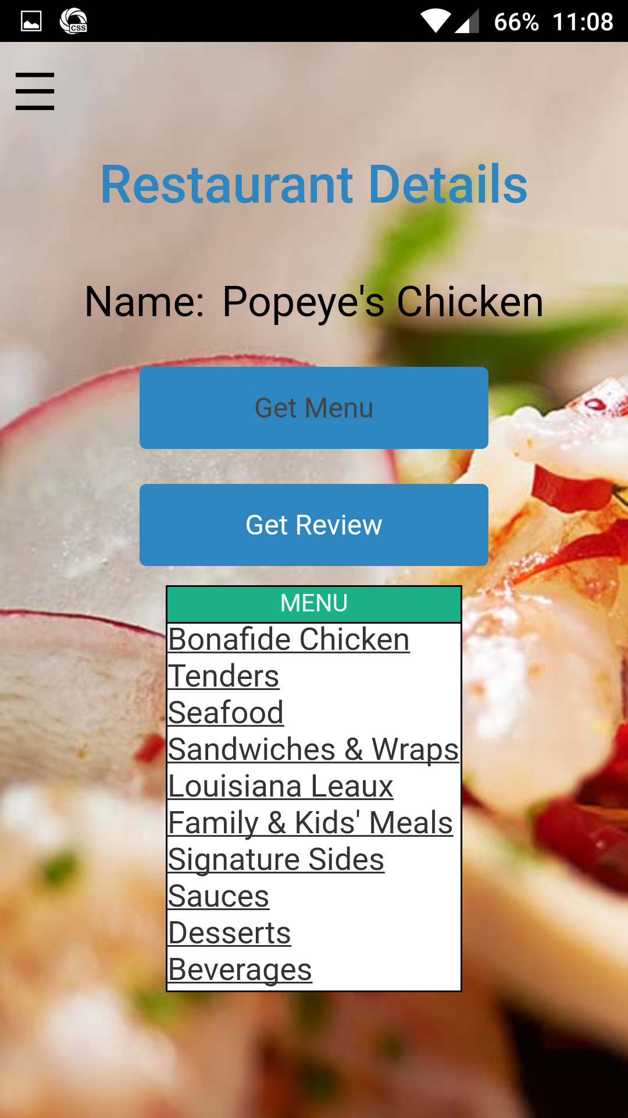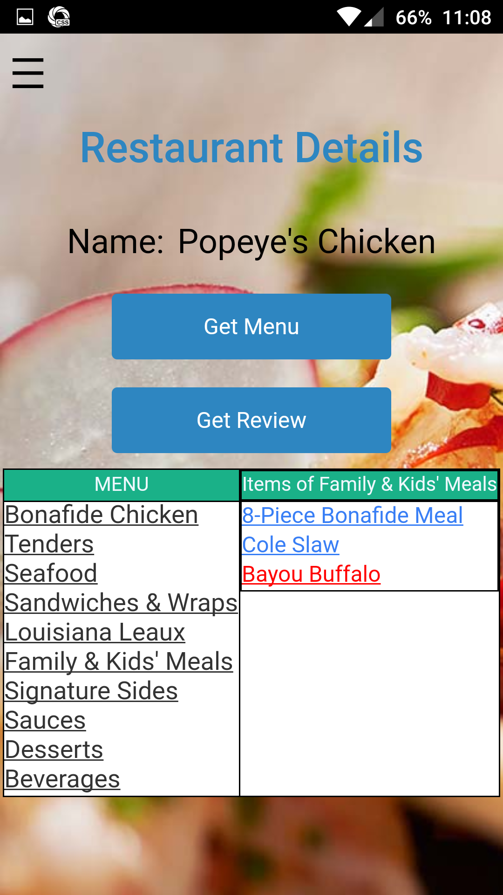

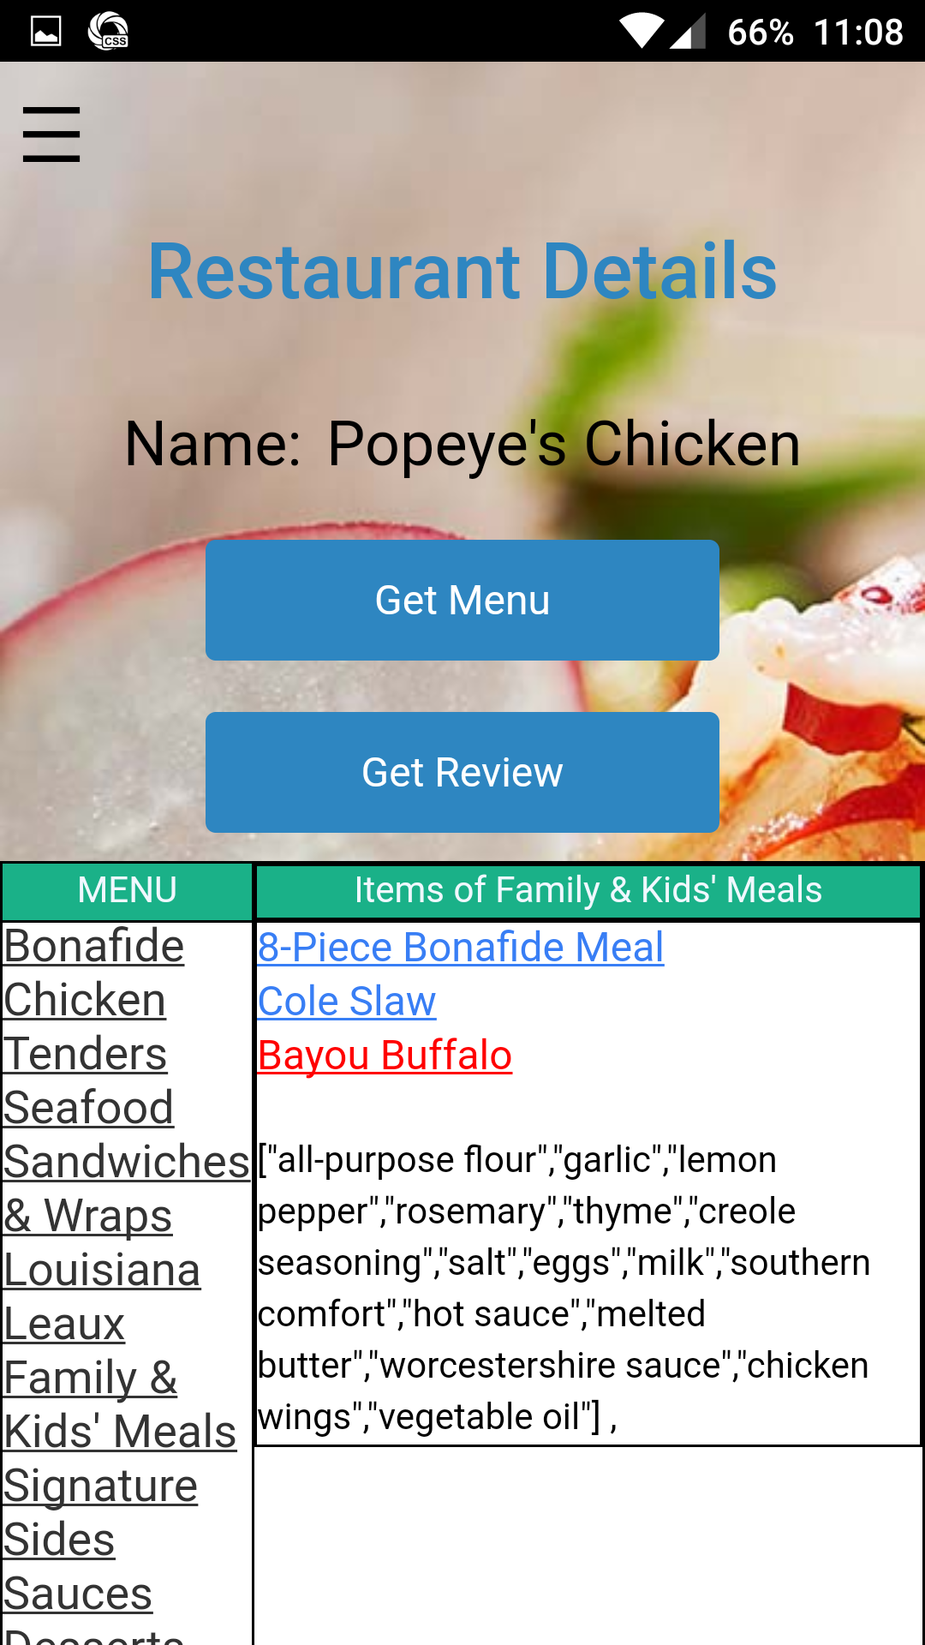

Translate page :

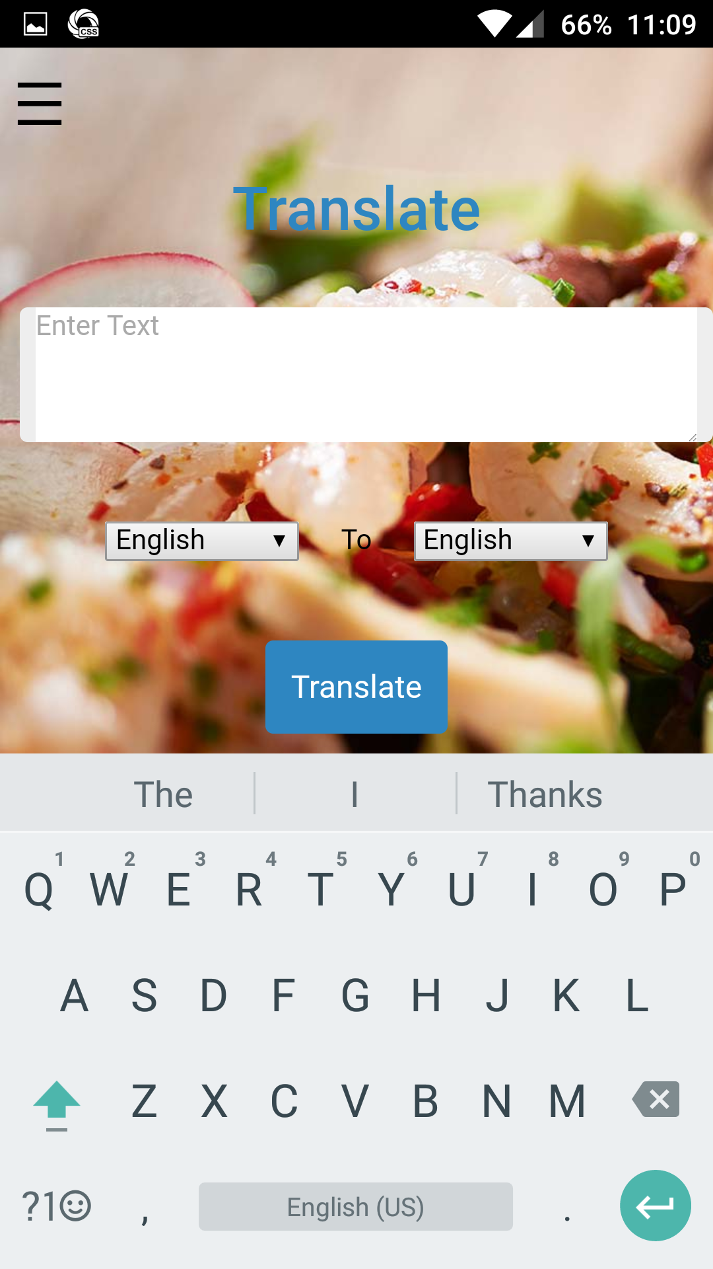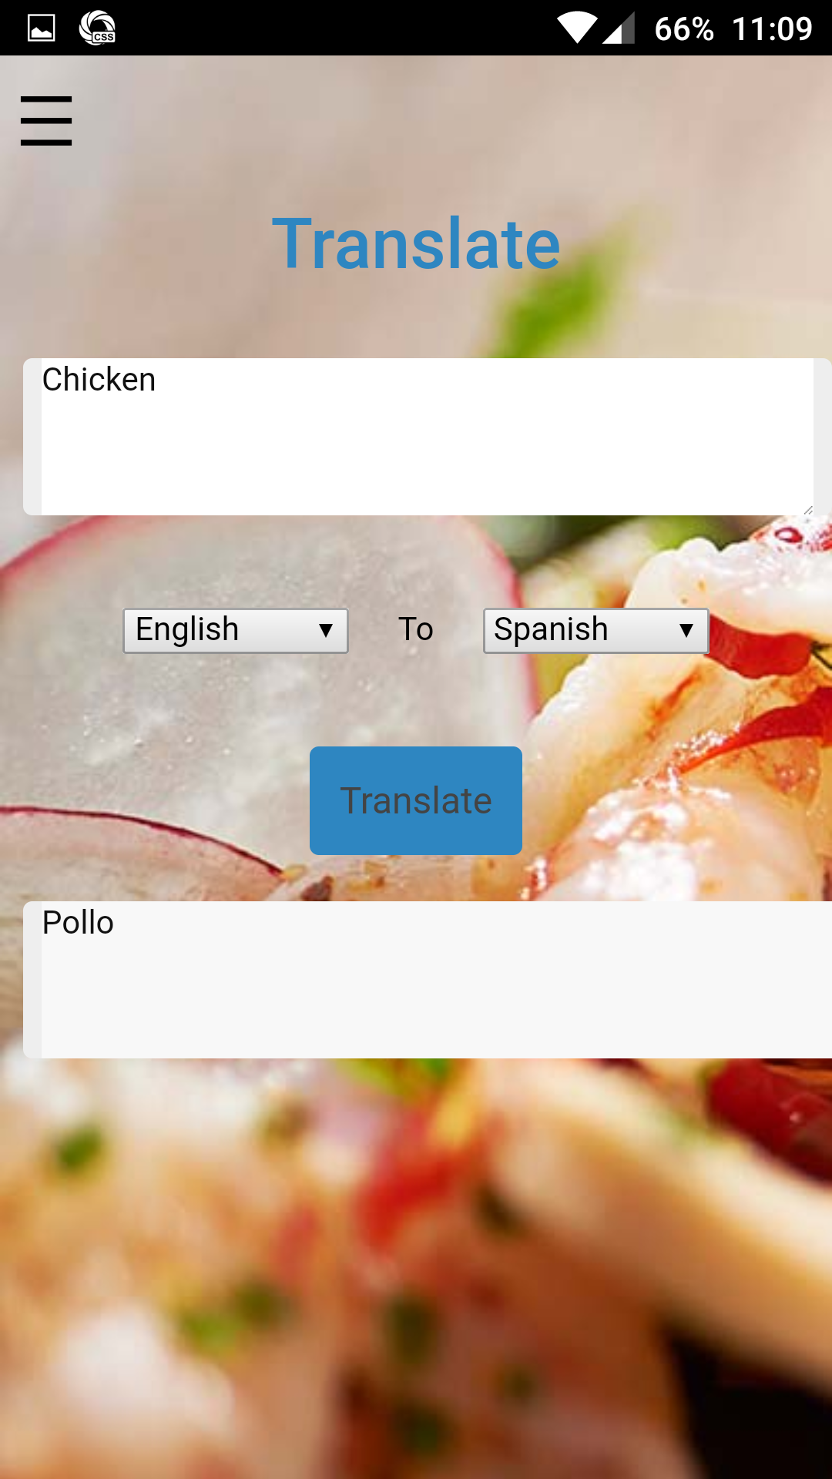

## **Web Application :**

we have deployed our application in web browser and android platform the web browser screen shoots are posted below android screen shots are posted already in above pages.

Web application login:

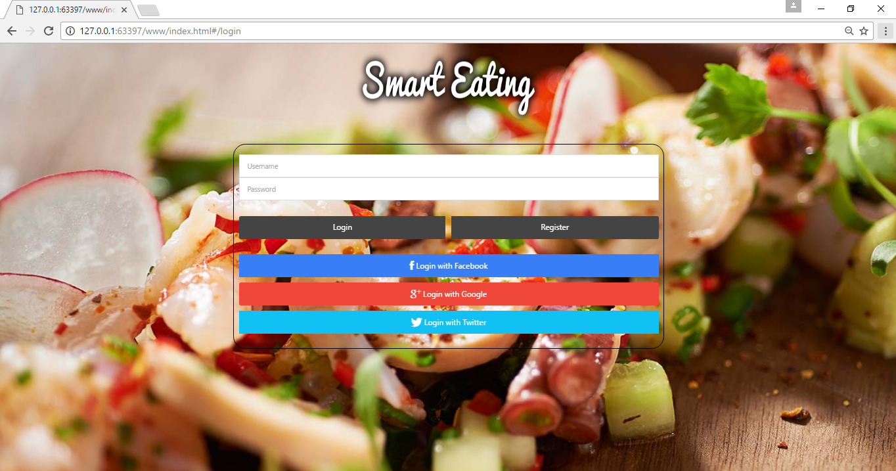

Home page:

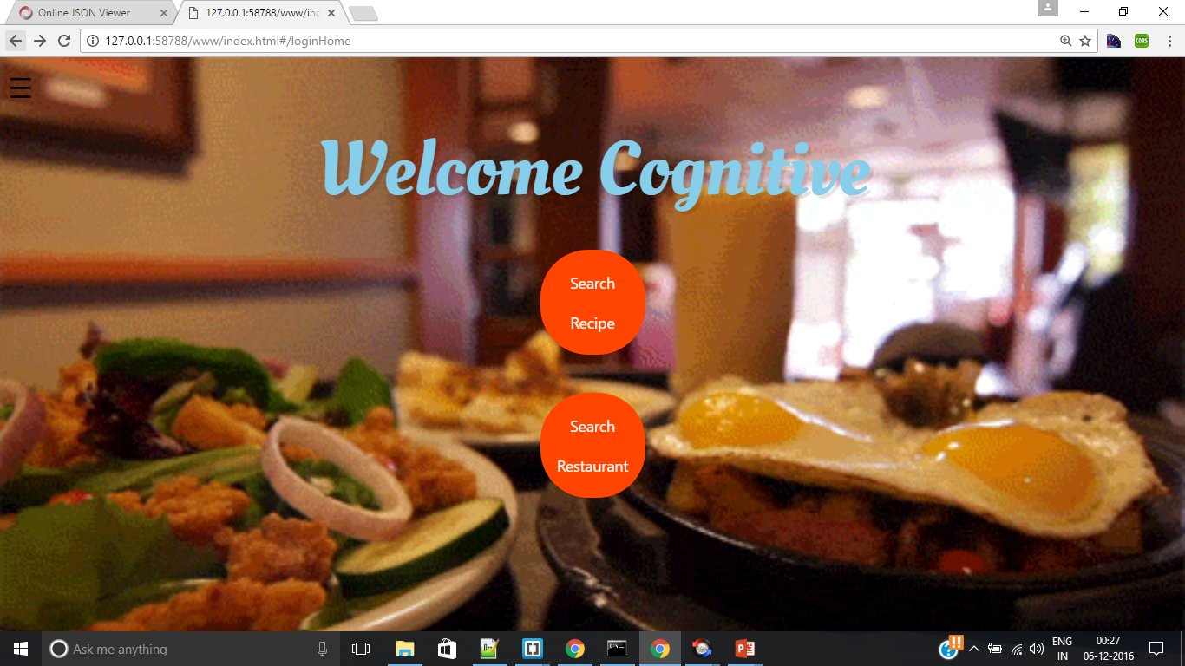

Search Recipe:

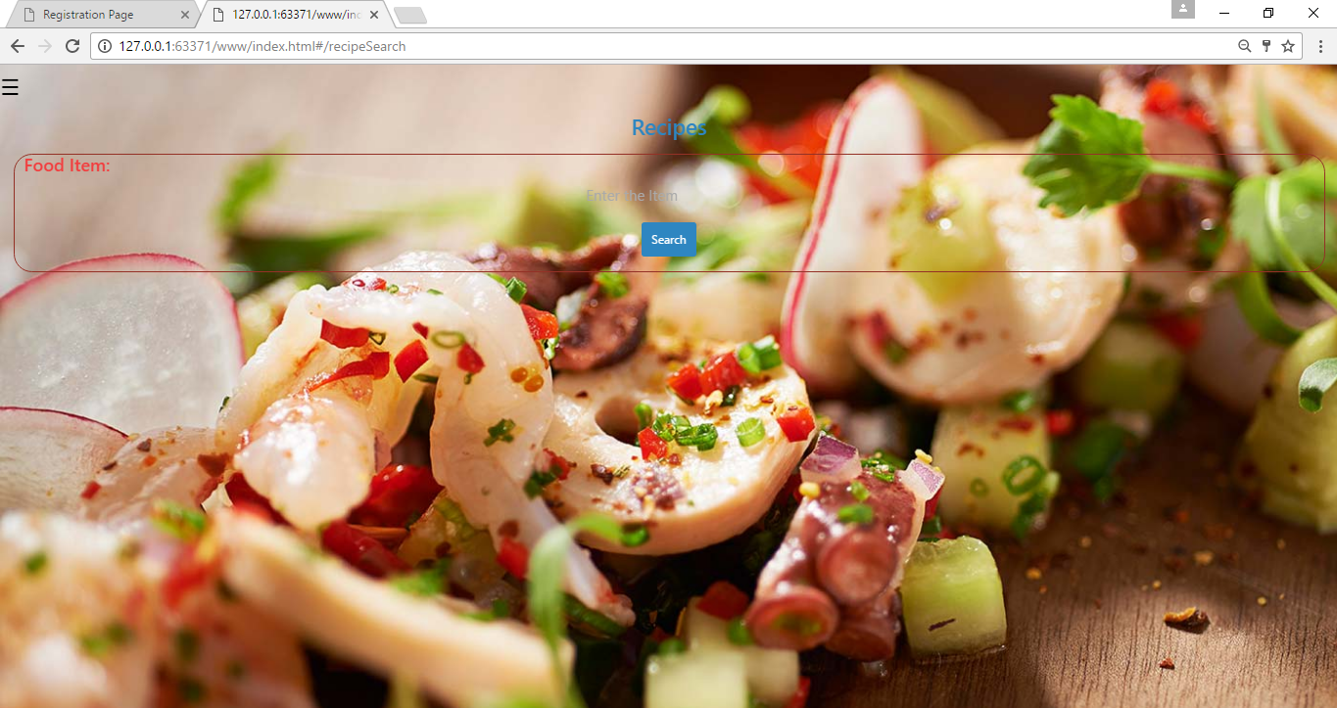

Search Restaurant:

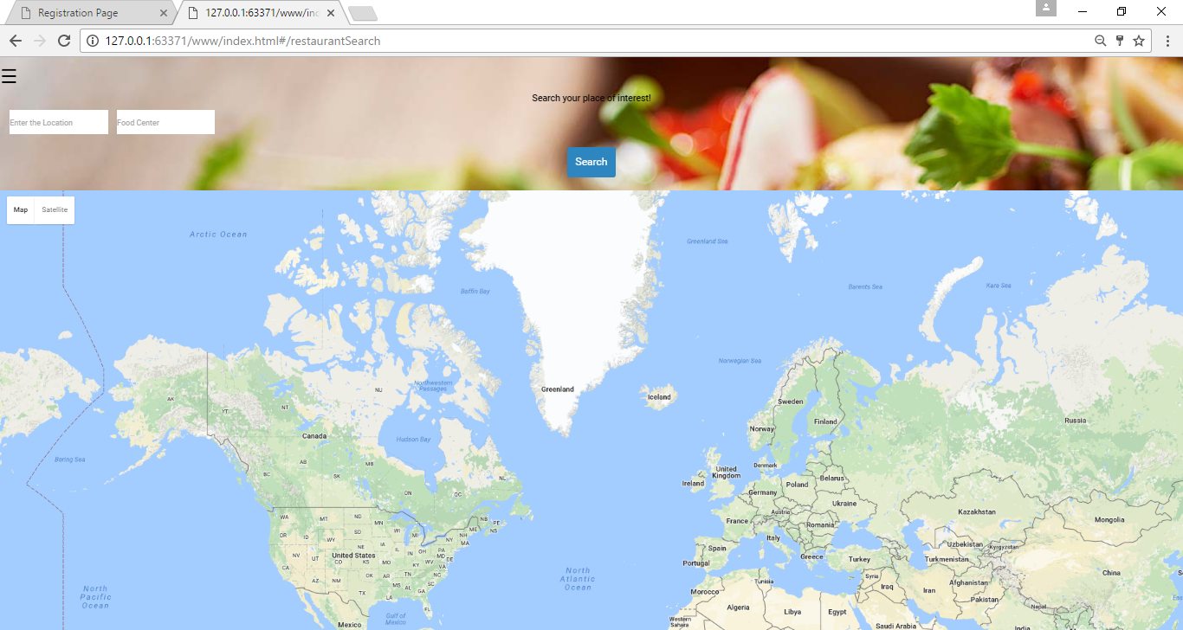

Side Menu :

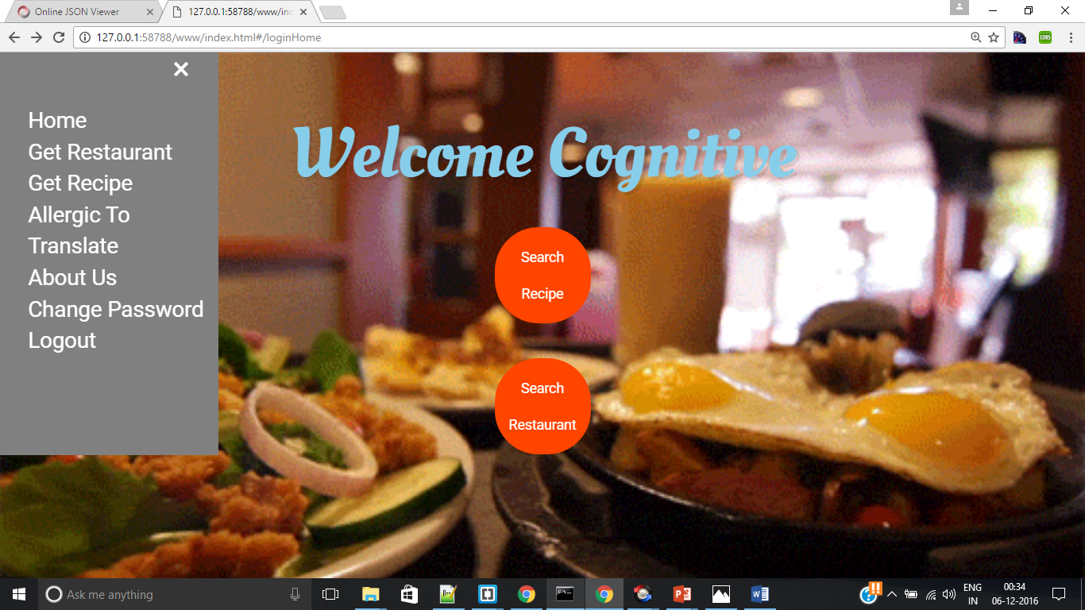

**Translate Page :**

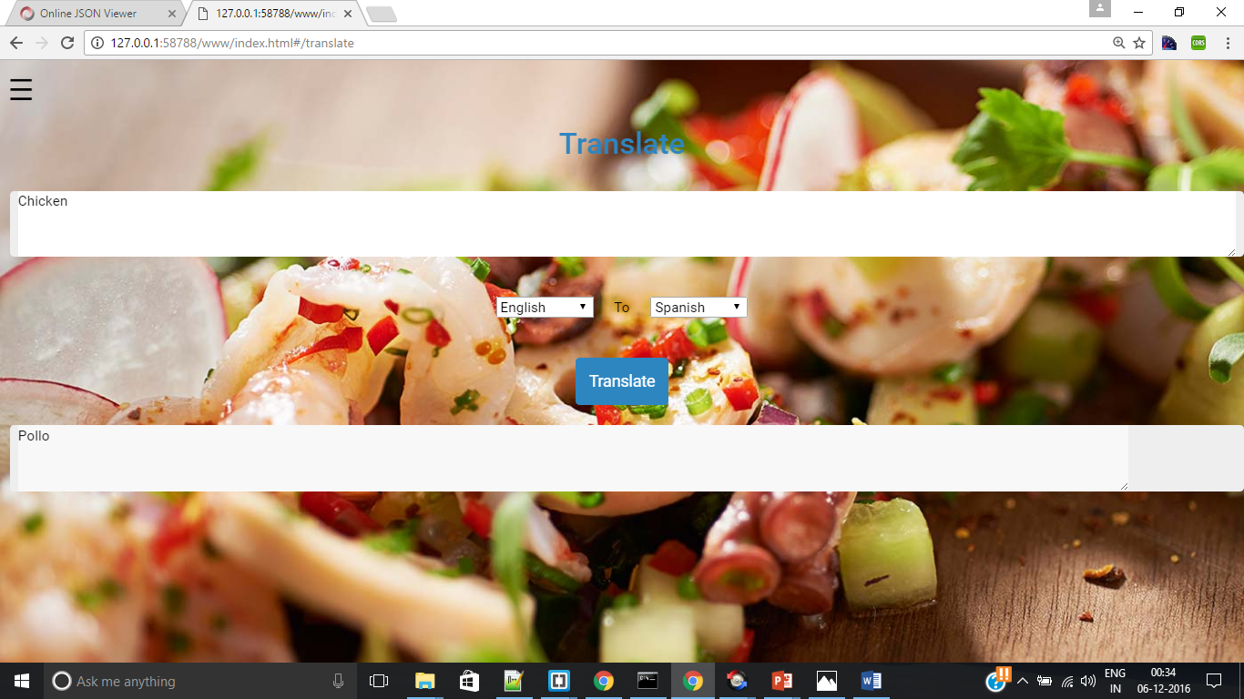

## Server Implementation:

Database for User account data:

In our project we are using the mlab online mongo dB data base, in this database we are storing the all the user information.

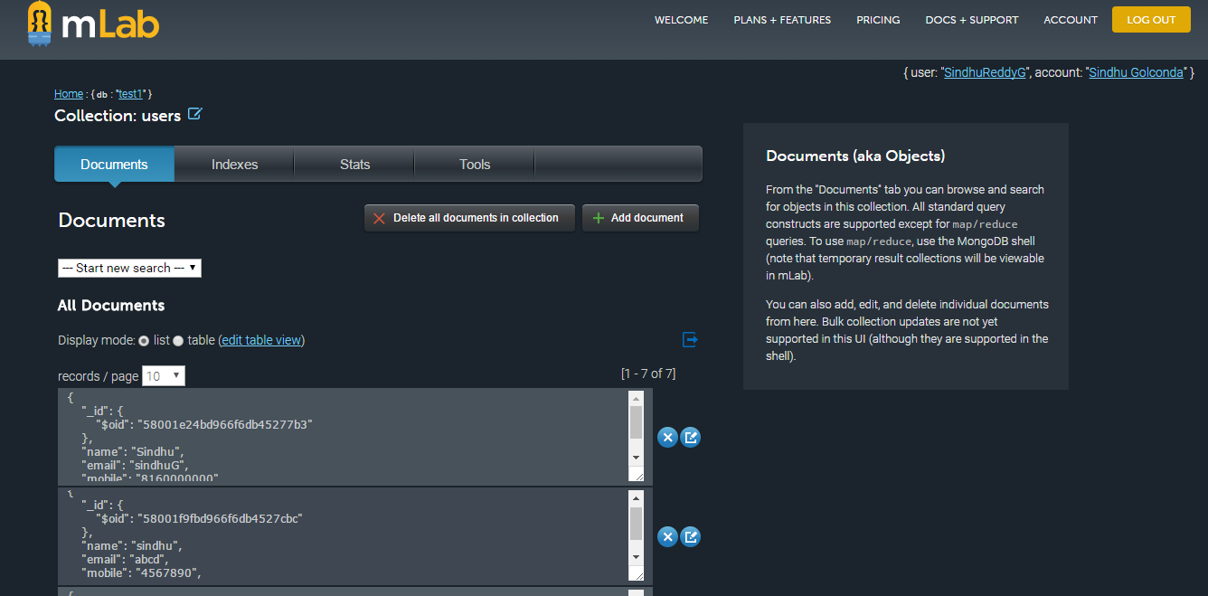

# Presentation Slides:

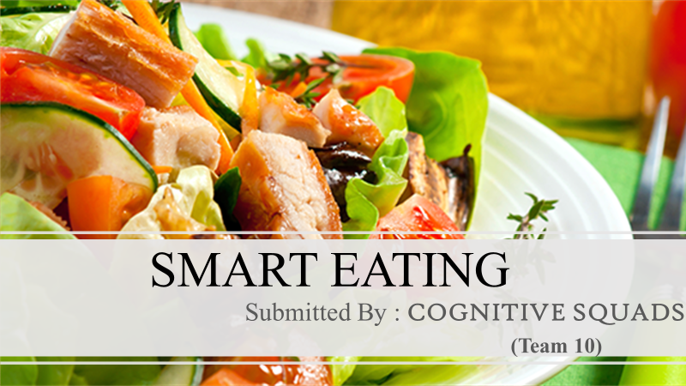

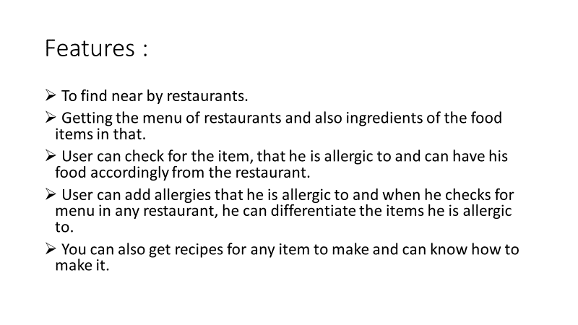

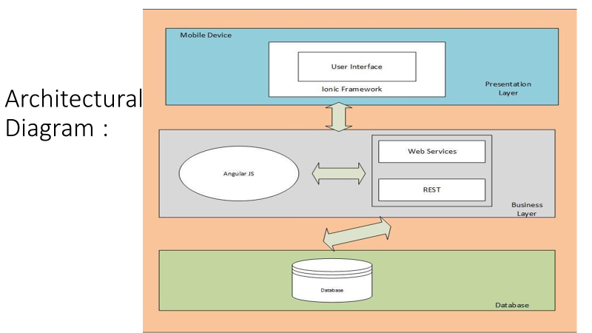

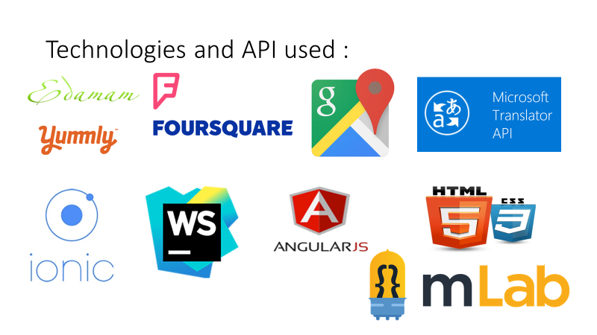



# GITHUB URL:

Source code GITHUB link is provide below:

Github URL:  [https://github.com/SindhuReddyG-sgdd7/CS551-Project-FoodGuid](https://github.com/SindhuReddyG-sgdd7/CS551-Project-FoodGuide)e

# YouTube URL:

<https://www.youtube.com/watch?v=EKLqClTXPWY>

# Bibliography:

<https://developers.google.com/knowledge-graph/how-tos/search-widge>t  [https://developer.foursquare.com/overview/realtim](https://developer.foursquare.com/overview/realtime)e  [https://webdesign.tutsplus.com/articles/making-websites-location-aware-with-html5-geolocation](https://webdesign.tutsplus.com/articles/making-websites-location-aware-with-html5-geolocation--webdesign-10495)- [-webdesign-1049](https://webdesign.tutsplus.com/articles/making-websites-location-aware-with-html5-geolocation--webdesign-10495)5

[http://www.w3schools.com/html/html5_geolocation.as](http://www.w3schools.com/html/html5_geolocation.asp)p  [http://www.w3schools.com/js/default.as](http://www.w3schools.com/js/default.asp)p  [https://www.jetbrains.com/webstorm/features/coding-assistance.htm](https://www.jetbrains.com/webstorm/features/coding-assistance.html)l  [https://developer.android.com/studio/intro/index.htm](https://developer.android.com/studio/intro/index.html)l  [http://mycaption.com/resources/technology/voice-recognitio](http://mycaption.com/resources/technology/voice-recognition)n

<https://colorlib.com/wp/html5-and-css3-login-forms/>

<https://cordova.apache.org/>